DQkNE
电动机/清洗机/自动化 Motor / cleaning machine / Automation
YE3 (DSF) series high efficient three-phase asynchronous motors for subway tunnel fans
YE3(DSF)系列高效率地铁隧道风机用三相异步电动机
YE3 (DSF) series high efficient three—phase asynchronous motors for subway tunnel fans
YE3(DSF)系列高效率地铁隧道风机用三相异步电动机
电动机/清洗机/自动化
Motor / cleaning machine / Automation
主要性能 Main Performance
•额定功率范围 Rated Power Range:0.75-315KW
•额定频率 Rated Frequency： 50Hz
•额定电压 Rated Voltage: 380V
•电机极数 Motor Poles: 2、4、6
•标准防护等级 International Protection Standard: IP55
绝缘系统：
按H级(180P )或C极(220P )设计，在额定输出和直接供电时 电机温升按80K考核，315机座号的2、4极以及355机座号的电机温升 允许达到105K;在250P环境温度下能正常运行2小时。
电动机冷却方式：标准冷却方式为IC411. IC410自扇冷，依靠轴伸端驱动的风机 带来的风进行冷却；
电机315-355、200及以上2极电机标配带注油嘴，132及以上电机可选配；
铸件材料：铸铁；
标准安装结构类型：IM B3、IM B5、IM B35等；
电机可选用PTC或PT100热敏电阻进行绕组保护，也可加装绕组测温装置，160以上电 机可以选配轴承测温装置；
特殊设计：我公司可根据客户要求设计特殊电压、频率的电机；可根据客户要求调 整电机外观颜色。
Insulation System:
According to the design of class H (180 DEG C) or class C ( 220 DEG C ) , in the rated output and direct power supply motor temperature rise according to 80K appraisal, 315 seat No. 2, 4 pole and 355 frame size motor temperature rise is allowed to reach 105K;
Cooling Method:standard cooling mode for IC410, IC411 self fan cooling, Wind driven by shaft extension end to cool the wind;
Motor 315-355, 200 and above 2 pole motor with standard oil nozzles, and more than 132 motor optional;
Material: cast iron castings;
Standard installation structure of: IM B3, IM B5, IM B35 etc.;
The motor can be used PTC or PT100 thermistor for winding protection, but also the installation of winding temperature measuring device, from frame 160 and up motor optional bearing temperature measuring device;
Special design: we can design special motor voltage and frequency according to customer requirements; can be adjusted according to customer requirements of motor appearance color.
安装与外形尺寸 Installation and configuration dimensions
H80-H200
H225-H280
 |  | Installation dimensions and tolerances 安装尺寸及公差
Frame size | Pole | A | B | C |  | D |  | E |  | F |  | G |  | H
机座号 |  | Basic dimenrsions 基本 尺寸 | Basic dimenrsions 基本 尺寸 | Basic dimenrsions 基本 尺寸 | LJmrt deviation 极限 偏差 | Basic dimenrsions 基本［ 尺寸 | LJmrt deviation 极限 偏差 | Basic dimenrsions 基本 尺寸 | Umft deviation 极限 偏差 | Basic dimenrsions 基本 尺寸 | LJmrt deviation 极限 偏差 | Basic dimenrsions 基本［ 尺寸 | LJmrt deviation 极限 偏差 | Basic dimenrsions 基本 尺寸 | Umft deviation 极限 偏差
80M |  | 125 | 100 | 50 |  | 19 |  | 40 |  | 6 | O  -0.030 | 15.5 | O -O.1 | 80
90S |  | 140 | 100 | 56 | ±1.5 | 24 | +0.009 | 50 | ±0.31 |  |  | 20 |  | 90
90L |  | 140 | 125 | 56 |  | 24 | -0.004 | 50 |  |  |  | 20
100L |  | 160 |  | 63 |  | 28 |  | 60 |  | 8 | 0 | 24 |  | 100
112M |  | 190 | 140 | 70 |  |  |  |  | ±H37 |  | -0.036 | 24 |  | 112
132S | 2~8 | 216 |  | 89 |  | 38 |  | 80 |  | 10 |  | 33 |  | 132 | 0
132M |  | 216 | 178 | 89 |  | 38 |  | 80 |  | 10 |  | 33 |  | 132 | -0.5
160M |  | 254 | 210 | 108 |  | 42 | +0.018 |  |  | 12 |  | 37 |  | 160
160L |  | 254 | 254 | 108 |  | 42 | +0.002 |  |  | 12
180M |  | 279 | 241 | 121 | ±3.0 | 48 |  | 110 | ±0.43 | 14 |  | 42*5 |  | 1B0
180L |  | 279 | 279 | 121 |  | 48 |  |  |  | 14
200L |  | 318 | 305 | 133 |  | 55 |  |  |  | 16 |  | 49 |  | 200
225S | 4~8 |  | 286 | 右149 左141 |  | 60 |  | 140 | ±0.50 | 18 | 0 | 53
225M | 2 | 356 | 311 | 右149 左141 |  | 55 |  | 110 | ±0.43 | 16 | -0.043 | 49 |  | 225
225M | 4~8 |  | 311 | 右149 左141 |  | 60 |  |  |  |  |  | 53
250M | 2 |  | 349 | 右168 |  | 60 |  |  |  | 18 |  | 53 | 0 | 250
250M | 4~8 |  | 349 | 左154 |  | 65 |  |  |  | 18 |  | 58 | -0.2 | 250
280S | 2 |  | 368 |  |  | 65
280S | 4~8 | 457 | 368 | 右190 |  | 75 | +0.030 | 140 |  | 20 | o  -0.052 | 67.5 |  | 280
280M | 2 | 457 | 419 | 左170 |  | 65 | +0.011 |  |  | 18 | O -0.043 | 58
280M | 4~8 |  | 419 |  |  | 75 |  |  |  | 20 | O -0.052 | 67.5
315S | 2 |  | 406 |  |  | 65 |  |  |  | 18 | O -0.043 | 58
315S | 4~10 |  | 406 |  |  | 80 |  | 170 | ±0.50 | 22 | O -0.052 | 71 |  |  | 0
315M | 2 | 508 | 457 | 216 | ±4.0 | 65 |  | 140 |  | 18 | O -0.043 | 58 |  | 315 | -1.0
315M | 4~10 |  |  |  |  | 80 |  | 170 |  | 22 | O -0.052 | 71
315L | 2 |  | 508 |  |  | 65 |  | 140 |  | 18 | O -0.043 | 58
315L | 4~10 |  | 508 |  |  | 80 |  | 170 |  | 22 |  | 71
355M | 2 |  | 560 | 右254 |  | 75 |  | 140 |  | 20 | 0 -0.052 | 67.5
355M | 4~10 | 610 | 560 | 左381 |  | 95 | +0.035 +0.013 | 170 |  | 25 | 0 -0.052 | 86 |  | 355
355L | 2 | 610 | 630 | 右254 |  | 75 | +0.030 +O.O11 | 140 |  | 20 | 0 -0.052 | 67.5 |  | 355
355L | 4~10 |  | 630 | 左311 |  | 95 | +0.035 +0.013 | 170 |  | 25 |  | 86

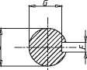
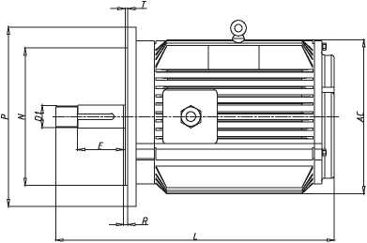
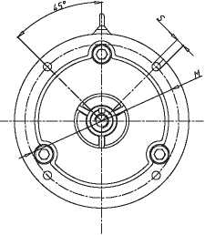
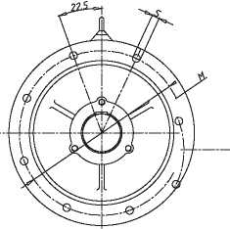
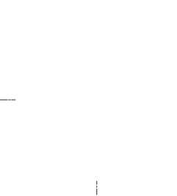

。站ME
电动疵洗枷自动化
Motor/cleaning machine / Automation
YE3 (DSF) series high efficient three-phase asynchronous motors for subway tunnel fans

YE3(DSF)系列高效率地铁隧道风机用三相异步电动机

YE3 (DSF) series high efficient three-phase asynchronous motors for subway tunnel fans

YE3(DSF)系列高效率地铁隧道风机用三相异步电动机
安装与外形尺寸 Installation and configuration dimensions

H80~H132
%
AB
性能数据 Performance Data
H160~H355
 |  |  |  | Power | Current 电流 |  |  | Torque 转矩 |  |  | Noise  噪声 dB(A) LW/LP | Moment
pe号 * | Power 功率 kW | Speed 转速 r/min | Eff. 效率  % | factor  功率 因素  cos 4) | 额定 电流 380V IN(A) | 额定 电流 400V IN(A) | 囂靄IST/IN | 额定 转矩 TN (N.M) | 堵转 转矩 额定 转矩 TST/tN | 最大 转矩 额定 转矩 TM/TN | Noise  噪声 dB(A) LW/LP | of inertia  转动 惯量 kg.m² | Weight 重量 kg

Synchronous speed 同步转速 3000r/min
Installation dimensions and tolerances 安装尺寸及公差 |  |  |  |  |  |  |  |  |  |  |  | Configuration dimensions 外形尺寸
K |  | M | N |  | P | R |  | S |  | T |  | AB | AC | BB | AD | L | D1
Basic dimenrsions 基本 尺寸 | Limit deviation 极限 偏差 | M | Basic dimenrsions 基本 尺寸 | Limit deviation 极限 偏差 | P | Basic dimenrsions 基本 尺寸 | Limit deviation 极限 偏差 | Basic dimenrsions 基本 尺寸 | Limit deviation 极限 偏差 | Basic dimenrsions 基本］ 尺寸 | Limit deviation 极限 偏差
10 | +0.36 0 | 165 | 130 | +0.014 -0.011 | 200 | 0 | ±1.5 | 12 | +0.43  0 | 3.5 | 0 -0.12 | 160 | 155 | 130 | 95 | 260 | M16x1.5
 |  |  |  |  |  |  |  |  |  |  |  | 176 | 175 | 140 | 100 | 285 | M20x1.5
 |  |  |  |  |  |  |  |  |  |  |  |  |  | 165 | 100 | 310 | M20x1.5
12 | +0.43  0 | 215 | 180 | +0.014 -0.011 | 250 | 0 | ±2.0 | 15 | +0.43  0 | 4.0 | 0 -0.12 | 200 | 196 | 175 | 109 | 350 | M24x1.5
 |  |  |  |  |  |  |  |  |  |  |  | 226 | 219 | 178 | 123 | 360 | M24x1.5
12 | +0.43  0 | 265 | 230 | +0.016 -0.013 | 300 |  |  |  |  |  |  | 262 | 260 | 185 | 149 | 420 | M36x1.5
 |  |  |  |  |  |  |  |  |  |  |  |  |  | 224 | 149 | 160 | M36x1.5
14.5 | +0.43  0 | 300 | 250 | +0.016 -0.013 | 350 | 0 | ±3.0 | 19 | +0.52  0 |  | 0 -0.12 | 314 | 315 | 260 | 184 | 560 | M36x1.5
 |  |  |  |  |  |  |  |  |  |  |  |  |  | 304 | 184 | 605 | M36x1.5
 |  |  |  |  |  |  |  |  |  |  |  | 349 | 358 | 310 | 205 | 630 | M42x1.5
 |  |  |  |  |  |  |  |  |  |  |  |  |  | 349 | 205 | 670 | M42x1.5
18.5 | +0.43  0 | 350 | 300 | ±0.016 | 400 | 0 | ±4.0 |  |  |  |  | 388 | 400 | 369 | 210 | 711 | M48x1.5
18.5 | +0.43  0 | 400 | 350 | ±0.018 | 450 |  |  |  |  |  |  | 431 | 448 | 368 | 235 | 745 | M56x2
 |  |  |  |  |  |  |  |  |  |  |  |  |  | 393 | 235 | 740 | M48x1.5
 |  |  |  |  |  |  |  |  |  |  |  |  |  |  |  | 770 | M56x2
24 | +0.52  0 | 500 | 450 | ±0.020 | 550 |  |  |  |  |  |  | 484 | 497 | 445 | 256 | 841 | M56x2
 |  |  |  |  |  |  |  |  |  |  |  |  |  |  |  |  | M56x2
 |  |  |  |  |  |  |  |  |  |  |  | 542 | 549 | 485 | 286 | 899 | M56x2
 |  |  |  |  |  |  |  |  |  |  |  |  |  |  |  |  | M64x2
 |  |  |  |  |  |  |  |  |  |  |  |  |  | 536 | 286 | 950 | M56x2
 |  |  |  |  |  |  |  |  |  |  |  |  |  |  |  |  | M64x2
28 | +0.52  0 | 600 | 550 | ±0.022 | 660 | 0 | ±4.0 | 24 | +0.52  0 | 6.0 | 0 -0.15 | 635 | 620 | 570 | 375 | 1048 | M56x2
 |  |  |  |  |  |  |  |  |  |  |  |  |  |  |  | 1078 | M72x2
 |  |  |  |  |  |  |  |  |  |  |  |  |  | 680 | 335 | 1153 | M56x2
 |  |  |  |  |  |  |  |  |  |  |  |  |  |  |  | 1183 | M72x2
 |  |  |  |  |  |  |  |  |  |  |  |  |  |  |  | 1153 | M56x2
 |  |  |  |  |  |  |  |  |  |  |  |  |  |  |  | 1183 | M72x2
28 | +0.52  0 | 740 | 680 | ±0.025 | 800 |  |  |  |  |  |  | 730 | 700 | 750 | 468 | 1369 | M72x2
 |  |  |  |  |  |  |  |  |  |  |  |  |  |  |  | 1399 | M90x2
 |  |  |  |  |  |  |  |  |  |  |  |  |  |  |  | 1369 | M72x2
 |  |  |  |  |  |  |  |  |  |  |  |  |  |  |  | 1399 | M90x2

YE3(DSF)-71M1-2 | 0.37 | 2800 | 69.0 | 0.81 | 1.0 | 0.95 | 5.5 | 1.2 | 2.3 | 2.3 | 64/56 | 0.0004 | 15
YE3(DSF)-71M2-2 | 0.55 | 2800 | 74.0 | 0.82 | 1.4 | 1.33 | 5.5 | 1.8 | 2.3 | 2.3 | 64/56 | 0.00055 | 16
YE3(DSF)-80M1-2 | 0.75 | 2825 | 80.7 | 0.83 | 1.7 | 1.62 | 6.8 | 2.5 | 2.3 | 2.3 | 64/56 | 0.005 | 19
YE3(DSF)-80M2-2 | 1.1 | 2825 | 82.7 | 0.83 | 2.43 | 2.31 | 7.3 | 3.7 | 2.3 | 2.3 | 64/56 | 0.007 | 22
YE3(DSF)-90S-2 | 1.5 | 2840 | 84.2 | 0.84 | 3.2 | 3.04 | 7.6 | 5.0 | 2.3 | 2.3 | 72/64 | 0.009 | 28
YE3(DSF)-90L-2 | 2.2 | 2840 | 85.9 | 0.85 | 4.6 | 4.4 | 7.8 | 7.4 | 2.3 | 2.3 | 72/64 | 0.017 | 33
YE3(DSF)-100L-2 | 3 | 2880 | 87.1 | 0.87 | 6.0 | 5.7 | 8.1 | 9.9 | 2.3 | 2.3 | 76/68 | 0.03 | 43
YE3(DSF)-112M-2 | 4 | 2890 | 88.1 | 0.87 | 7.9 | 7.5 | 8.3 | 13.2 | 2.2 | 2.3 | 77/69 | 0.063 | 53
YE3(DSF)-132S1-2 | 5.5 | 2900 | 89.2 | 0.88 | 10.7 | 10.2 | 8.0 | 18.1 | 2.2 | 2.3 | 80/72 | 0.073 | 71
YE3(DSF)-132S2-2 | 7.5 | 2900 | 90.1 | 0.88 | 14.4 | 13.7 | 7.8 | 24.7 | 2.2 | 2.3 | 80/72 | 0.21 | 79
YE3(DSF)-160M1-2 | 11 | 2930 | 91.2 | 0.88 | 20.8 | 19.8 | 7.9 | 35.8 | 2.2 | 2.3 | 82/74 | 0.25 | 124
YE3(DSF)-160M2-2 | 15 | 2930 | 91.9 | 0.88 | 28.2 | 26.8 | 8.0 | 48.8 | 2.2 | 2.3 | 82/74 | 0.31 | 135
YE3(DSF)-160L-2 | 18.5 | 2930 | 92.4 | 0.88 | 34.6 | 32.9 | 8.1 | 60 | 2.2 | 2.3 | 82/74 | 0.37 | 145
YE3(DSF)-180M-2 | 22 | 2940 | 92.7 | 0.89 | 40 | 38 | 8.2 | 71 | 2.2 | 2.3 | 85/77 | 0.63 | 202
YE3(DSF)-200L1-2 | 30 | 2950 | 93.3 | 0.89 | 55 | 52.3 | 7.5 | 97 | 2.2 | 2.3 | 87/79 | 0.73 | 242
YE3(DSF)-200L2-2 | 37 | 2950 | 93.7 | 0.89 | 67 | 63.7 | 7.5 | 119 | 2.2 | 2.3 | 87/79 | 1.28 | 264
YE3(DSF)-225M-2 | 45 | 2970 | 94.0 | 0.89 | 82 | 77.9 | 7.6 | 144 | 2.2 | 2.3 | 89/82 | 1.55 | 308
YE3(DSF)-250M-2 | 55 | 2970 | 94.3 | 0.89 | 99 | 94.1 | 7.6 | 176 | 2.2 | 2.3 | 89/82 | 1.89 | 398
YE3(DSF)-280S-2 | 75 | 2970 | 94.7 | 0.89 | 135 | 128.3 | 6.9 | 241 | 2.0 | 2.3 | 91/83 | 2.02 | 530
YE3(DSF)-280M-2 | 90 | 2970 | 95.0 | 0.89 | 162 | 154 | 7.0 | 289 | 2.0 | 2.3 | 91/83 | 2.26 | 590
YE3(DSF)-315S-2 | 110 | 2980 | 95.2 | 0.89 | 197 | 183 | 7.1 | 352 | 2.0 | 2.2 | 95/85 | 2.42 | 910
YE3(DSF)-315M-2 | 132 | 2980 | 95.4 | 0.89 | 236 | 224 | 7.1 | 423 | 2.0 | 2.2 | 95/85 | 2.726 | 1015
YE3(DSF)-315L1-2 | 160 | 2980 | 95.6 | 0.89 | 286 | 272 | 7.1 | 512 | 2.0 | 2.2 | 95/85 | 3.22 | 1080
YE3(DSF)-315L-2 | 185 | 2980 | 95.7 | 0.9 | 326 | 310 | 7.1 | 592 | 2.0 | 2.2 | 95/85 | 3.41 | 1135
YE3(DSF)-315L2-2 | 200 | 2980 | 95.8 | 0.9 | 352 | 334 | 7.1 | 640 | 2.0 | 2.2 | 95/85 | 3.86 | 1135
YE3(DSF)-355S1-2 | 185 | 2980 | 95.8 | 0.9 | 326 | 310 | 7.1 | 592 | 2.0 | 2.2 | 98/88 | 4.82 | 1520
YE3(DSF)-355S2-2 | 200 | 2980 | 95.8 | 0.9 | 352 | 334 | 7.1 | 640 | 2.0 | 2.2 | 98/88 | 5.46 | 1540
YE3(DSF)-355M1-2 | 220 | 2980 | 95.8 | 0.9 | 388 | 369 | 7.1 | 705 | 2.0 | 2.2 | 98/88 | 6.22 | 1610
YE3(DSF)-355M2-2 | 250 | 2980 | 95.8 | 0.9 | 441 | 419 | 7.1 | 801 | 2.0 | 2.2 | 98/88 | 6.54 | 1650
YE3(DSF)-355L1-2 | 280 | 2980 | 95.8 | 0.9 | 493 | 468 | 7.1 | 897 | 2.0 | 2.2 | 98/88 | 6.95 | 1700
YE3(DSF)-355L2-2 | 315 | 2980 | 95.8 | 0.9 | 555 | 527 | 7.1 | 1009 | 2.0 | 2.2 | 98/88 | 7.06 | 1830

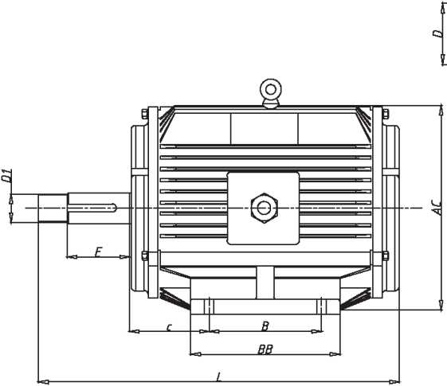
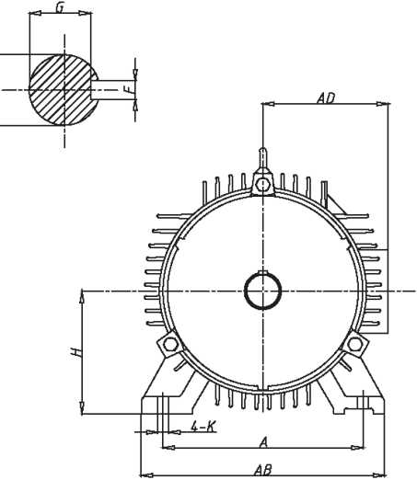
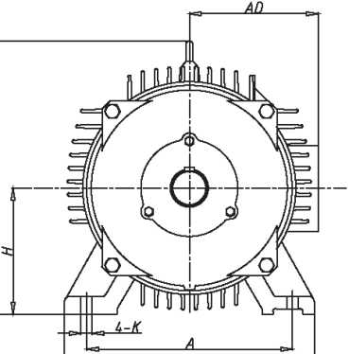

。站ME
电动枷清洗初自动化
Motor/cleaning machine / Automation
DfikNE
电动机鶴洗机/自动化
Motor/cleaning machine/ Automation
YE3 (DSF) series high efficient three-phase asynchronous motors for subway tunnel fans

YE3(DSF)系列高效率地铁隧道风机用三相异步电动机

YE3 (DSF) series high efficient three-phase asynchronous motors for subway tunnel fans

YE3(DSF)系列高效率地铁隧道风机用三相异步电动机

性能数据 Performance Data
性能数据 Performance Data

 |  |  |  | Power | Current 电流 |  |  | Torque 转矩 |  |  | Noise 噪声 dB(A) LW/LP | Moment
pe号 * | Power 功率 kW | Speed 转速 r/min | Eff. 效率  % | factor 功率 因素 COS。 | 额定 电流 380V IN(A) | 额定 电流 400V IN(A) | 囂靄1 | 额定 转矩 TN (N.M) | 堵转 转矩 额定 转矩 TSTg | 最大 转矩 额定 转矩 TM/TN | Noise 噪声 dB(A) LW/LP | of inertia 转动 惯量 kg.m² | Weight 重量 kg
Synchronous speed 同步转速 1500r/min

YE3(DSF)-71M1-4 | 0.25 | 1400 | 65.0 | 0.74 | 0.8 | 0.76 | 5.0 | 1.7 | 2.1 | 2.2 | 54/46 | 0.0007 | 15
YE3(DSF)-71M2-4 | 0.37 | 1400 | 67.0 | 0.75 | 1.1 | 1.05 | 5.0 | 2.5 | 2.1 | 2.2 | 54/46 | 0.00097 | 16
YE3(DSF)-80M1-4 | 0.55 | 1390 | 76.5 | 0.75 | 1.5 | 1.43 | 6.3 | 3.7 | 2.3 | 2.3 | 58/50 | 0.007 | 22
YE3(DSF)-80M2-4 | 0.75 | 1390 | 82.5 | 0.75 | 1.8 | 1.71 | 6.5 | 5.1 | 2.3 | 2.3 | 58/50 | 0.012 | 24
YE3(DSF)-90S-4 | 1.1 | 1400 | 84.1 | 0.75 | 2.65 | 2.52 | 6.6 | 7.5 | 2.3 | 2.3 | 61/53 | 0.015 | 32
YE3(DSF)-90L-4 | 1.5 | 1400 | 85.3 | 0.75 | 3.6 | 3.4 | 6.9 | 10.2 | 2.3 | 2.3 | 61/53 | 0.031 | 36
YE3(DSF)-100L1-4 | 2.2 | 1420 | 86.7 | 0.81 | 4.8 | 4.6 | 7.5 | 14.8 | 2.3 | 2.3 | 64/56 | 0.039 | 43
YE3(DSF)-100L2-4 | 3 | 1420 | 87.7 | 0.82 | 6.3 | 6 | 7.6 | 20.1 | 2.3 | 2.3 | 64/56 | 0.059 | 49
YE3(DSF)-112M-4 | 4 | 1440 | 88.6 | 0.82 | 8.4 | 8 | 7.7 | 26.5 | 2.3 | 2.3 | 65/57 | 0.113 | 63
YE3(DSF)-132S-4 | 5.5 | 1440 | 89.6 | 0.82 | 11.4 | 10.8 | 7.5 | 36.4 | 2.0 | 2.3 | 71/63 | 0.167 | 80
YE3(DSF)-132M-4 | 7.5 | 1440 | 90.4 | 0.83 | 15.2 | 14.4 | 7.4 | 49 | 2.0 | 2.3 | 71/63 | 0.36 | 100
YE3(DSF)-160M-4 | 11 | 1460 | 91.4 | 0.85 | 21.5 | 20.4 | 7.5 | 71 | 2.2 | 2.3 | 74/66 | 0.42 | 126
YE3(DSF)-160L-4 | 15 | 1460 | 92.1 | 0.85 | 29.1 | 27.6 | 7.5 | 98 | 2.2 | 2.3 | 74/66 | 0.68 | 148
YE3(DSF)-180M-4 | 18.5 | 1470 | 92.6 | 0.86 | 35.3 | 33.5 | 7.7 | 120 | 2.2 | 2.3 | 76/68 | 0.72 | 190
YE3(DSF)-180L-4 | 22 | 1470 | 93.0 | 0.86 | 41.8 | 39.7 | 7.8 | 142 | 2.2 | 2.3 | 76/68 | 0.81 | 205
YE3(DSF)-200L-4 | 30 | 1470 | 93.6 | 0.86 | 56.6 | 53.8 | 7.2 | 194 | 2.2 | 2.3 | 79/71 | 1.21 | 260
YE3(DSF)-225S-4 | 37 | 1480 | 93.9 | 0.86 | 70 | 66.5 | 7.3 | 238 | 2.2 | 2.3 | 81/73 | 1.85 | 312
YE3(DSF)-225M-4 | 45 | 1480 | 94.2 | 0.86 | 84 | 79.8 | 7.4 | 290 | 2.2 | 2.3 | 81/73 | 2.32 | 338
YE3(DSF)-250M-4 | 55 | 1480 | 94.6 | 0.86 | 103 | 97.9 | 7.4 | 354 | 2.2 | 2.3 | 82/74 | 2.86 | 412
YE3(DSF)-280S-4 | 75 | 1480 | 95.0 | 0.87 | 138 | 131.1 | 6.7 | 483 | 2.0 | 2.3 | 85/77 | 3.34 | 574
YE3(DSF)-280M-4 | 90 | 1485 | 95.2 | 0.87 | 165 | 157 | 6.9 | 578 | 2.0 | 2.3 | 85/77 | 4.68 | 650
YE3(DSF)-315S-4 | 110 | 1485 | 95.4 | 0.87 | 201 | 191 | 6.9 | 707 | 2.0 | 2.2 | 91/79 | 4.96 | 935
YE3(DSF)-315M-4 | 132 | 1485 | 95.6 | 0.88 | 238 | 226 | 6.9 | 848 | 2.0 | 2.2 | 91/79 | 5.22 | 1032
YE3(DSF)-315L1-4 | 160 | 1485 | 95.8 | 0.88 | 288 | 274 | 6.9 | 1028 | 2.0 | 2.2 | 91/79 | 5.43 | 1105
YE3(DSF)-315L-4 | 185 | 1485 | 95.9 | 0.89 | 329 | 313 | 6.9 | 1189 | 2.0 | 2.2 | 91/79 | 5.62 | 1205
YE3(DSF)-315L2-4 | 200 | 1485 | 96.0 | 0.89 | 356 | 338 | 6.9 | 1286 | 2.0 | 2.2 | 91/79 | 6.45 | 1205
YE3(DSF)-355S1-4 | 185 | 1488 | 96.0 | 0.89 | 329 | 313 | 6.9 | 1187 | 2.0 | 2.2 | 94/82 | 6.56 | 1550
YE3(DSF)-35552-4 | 200 | 1488 | 96.0 | 0.9 | 352 | 334 | 6.9 | 1283 | 2.0 | 2.2 | 94/82 | 6.88 | 1590
YE3(DSF)-355M1-4 | 220 | 1488 | 96.0 | 0.9 | 387 | 368 | 6.9 | 1411 | 2.0 | 2.2 | 94/82 | 7.22 | 1620
YE3(DSF)-355M2-4 | 250 | 1488 | 96.0 | 0.9 | 440 | 418 | 6.9 | 1604 | 2.0 | 2.2 | 94/82 | 7.46 | 1685
YE3(DSF)-355L1-4 | 280 | 1488 | 96.0 | 0.9 | 492 | 467 | 6.9 | 1797 | 2.0 | 2.2 | 94/82 | 7.68 | 1690
YE3(DSF)-355L2-4 | 315 | 1488 | 96.0 | 0.9 | 554 | 526 | 6.9 | 2021 | 2.0 | 2.2 | 94/82 | 7.8 | 1780

pe号 * | Power 功率 kW | Speed 转速 r/min | Eff. 效率  % | Power factor 功率 因素 cos(|) | Current 电流 |  |  | Torque 转矩 |  |  | Noise 噪声 dB(A) LW/LP | Moment of inertia 转动 惯量 kg.m² | Weight 重量 kg
 |  |  |  |  | 额定 电流 380V IN(A) | 额定 电流 400V IN(A) | 囂靄1 | 额定 转矩 TN (N.M) | 堵转 转矩 额定 转矩 TST/TN | 最大 转矩 额定 转矩 TM/TN | Noise 噪声 dB(A) LW/LP | Moment of inertia 转动 惯量 kg.m² | Weight 重量 kg
Synchronous speed 同步转速 10OOr/min
YE3(DSF)-71M1-6 | 0.18 | 900 | 56.0 | 0.68 | 0.8 | 0.76 | 4.0 | 2.0 | 2.0 | 2.1 | 52/44 | 0.0007 | 15
YE3(DSF)-71M2-6 | 0.25 | 900 | 59.0 | 0.68 | 0.9 | 0.86 | 4.0 | 2.8 | 2.0 | 2.1 | 52/44 | 0.0011 | 16
YE3(DSF)-80M1-6 | 0.37 | 910 | 71.4 | 0.71 | 1.1 | 1.05 | 4.7 | 3.8 | 1.9 | 2.0 | 54/46 | 0.039 | 19
YE3(DSF)-80M2-6 | 0.55 | 910 | 74.2 | 0.72 | 1.6 | 1.5 | 4.7 | 5.7 | 1.9 | 2.1 | 54/46 | 0.059 | 20
YE3(DSF)-90S-6 | 0.75 | 910 | 78.9 | 0.73 | 2.0 | 1.9 | 5.8 | 7.8 | 2.1 | 2.1 | 57/49 | 0.113 | 29
YE3(DSF)-90L-6 | 1.1 | 910 | 81.0 | 0.73 | 2.8 | 2.7 | 5.9 | 11.5 | 2.1 | 2.1 | 57/49 | 0.167 | 36
YE3(DSF)-100L-6 | 1.5 | 940 | 82.5 | 0.74 | 3.7 | 3.5 | 6.0 | 15.2 | 2.1 | 2.1 | 61/53 | 0.36 | 44
YE3(DSF)-112M-6 | 2.2 | 940 | 84.3 | 0.74 | 5.4 | 5.1 | 6.0 | 22.3 | 2.1 | 2.1 | 65/57 | 0.42 | 54
YE3(DSF)-132S-6 | 3 | 960 | 85.6 | 0.74 | 7.2 | 6.8 | 6.2 | 29.8 | 2.0 | 2.1 | 69/62 | 0.68 | 69
YE3(DSF)-132M1-6 | 4 | 960 | 86.8 | 0.75 | 9.3 | 8.8 | 6.8 | 39.7 | 2.0 | 2.1 | 69/62 | 0.72 | 88
YE3(DSF)-132M2-6 | 5.5 | 960 | 88.0 | 0.78 | 12.2 | 11.6 | 7.1 | 54 | 2.0 | 2.1 | 69/62 | 0.81 | 101
YE3(DSF)-160M-6 | 7.5 | 970 | 89.1 | 0.79 | 16.2 | 15.4 | 6.7 | 73 | 2.1 | 2.1 | 70/62 | 1.21 | 125
YE3(DSF)- 160L-6 | 11 | 970 | 90.3 | 0.79 | 23.4 | 22.3 | 6.9 | 108 | 2.1 | 2.1 | 70/62 | 1.32 | 140
YE3(DSF)-180L-6 | 15 | 970 | 91.2 | 0.81 | 30.9 | 29.4 | 7.2 | 147 | 2.0 | 2.1 | 70/62 | 1.62 | 190
YE3(DSF)-200L1-6 | 18.5 | 970 | 91.7 | 0.82 | 37.4 | 35.5 | 7.2 | 182 | 2.1 | 2.1 | 76/68 | 1.84 | 230
YE3(DSF)-200L2-6 | 22 | 970 | 92.2 | 0.82 | 44 | 41.8 | 7.3 | 216 | 2.1 | 2.1 | 76/68 | 2.43 | 250
YE3(DSF)-225M-6 | 30 | 980 | 92.9 | 0.84 | 58 | 55.1 | 7.1 | 292 | 2.0 | 2.1 | 76/68 | 2.68 | 292
YE3(DSF)-250M-6 | 37 | 980 | 93.3 | 0.85 | 71 | 67.5 | 7.1 | 360 | 2.1 | 2.1 | 78/70 | 3.46 | 380
YE3(DSF)-280S-6 | 45 | 980 | 93.7 | 0.85 | 86 | 81.7 | 7.2 | 438 | 2.1 | 2.0 | 80/72 | 3.97 | 500
YE3(DSF)-280M-6 | 55 | 980 | 94.1 | 0.85 | 104 | 98.8 | 7.2 | 535 | 2.1 | 2.0 | 80/72 | 4.57 | 562
YE3(DSF)-315S-6 | 75 | 985 | 94.6 | 0.85 | 142 | 135 | 6.7 | 727 | 2.0 | 2.0 | 85/73 | 4.83 | 872
YE3(DSF)-315M-6 | 90 | 985 | 94.9 | 0.85 | 170 | 162 | 6.7 | 872 | 2.0 | 2.0 | 85/73 | 5.32 | 963
YE3(DSF)-315L1-6 | 110 | 985 | 95.1 | 0.86 | 204 | 194 | 6.7 | 1066 | 2.0 | 2.0 | 85/73 | 5.95 | 1072
YE3(DSF)-315L2-6 | 132 | 985 | 95.4 | 0.86 | 244 | 232 | 6.7 | 1279 | 2.0 | 2.0 | 85/73 | 7.32 | 1180
YE3(DSF)-355S-6 | 160 | 985 | 95.6 | 0.87 | 292 | 277 | 6.7 | 1551 | 2.0 | 2.0 | 91/79 | 7.89 | 1680
YE3(DSF)-355M1-6 | 185 | 985 | 95.7 | 0.87 | 338 | 321 | 6.7 | 1793 | 2.0 | 2.0 | 91/79 | 8.17 | 1790
YE3(DSF)-355M2-6 | 200 | 985 | 95.8 | 0.87 | 365 | 347 | 6.7 | 1939 | 2.0 | 2.0 | 91/79 | 8.25 | 1790
YE3(DSF)-355L1-6 | 220 | 985 | 95.8 | 0.87 | 401 | 381 | 6.7 | 2132 | 2.0 | 2.0 | 91/79 | 8.36 | 1830
YE3(DSF)-355L2-6 | 250 | 985 | 95.8 | 0.88 | 451 | 429 | 6.7 | 2423 | 2.0 | 2.0 | 91/79 | 8.38 | 2045

DQANE
电动机/清洗机/自动化
Motor / cleaning machine / Automation
DfiANE
电动机/清洗机/自动化
Motor / cleaning machine / Automation
YDT3 series Pole-changing Three Phase Induction Asynchronous Motors
YDT3系列变极多速三相异步电动机

YDT3 series Pole-changing Three Phase Asynchronous Motors
YDT3系列变极多速三相异步电动机

YDT3系列变级多速三相异步电动机是我公司在YDT系列电机基础上进行自主研发形 成的一款变极调速电机。电机采用先进的设计理念；成熟、精密的加工工艺；优质高端 的原材料，具有结构紧凑、能效高、噪声低、振动小、运转平稳可靠、使用寿命长等特 点。
尤其在电机设计时充分考虑到匹配风机、泵类的负载特性，高低速功率分配更合理， 电机在高低速时均能更好匹配负载，不会在低速时出线严重轻载现象，整个调速系统的 能效更高。
电机为风机、水泵类负载专用驱动电机。
YDT3 series Pole-changing multi-speed three-phase asynchronous motor is our company independent research and development of a variable speed motor. Motor adopts advanced design concepts; mature, precision processing technology; high quality raw materials, with compact structure, high efficiency, low noise, small vibration, stable and reliable operation, long life and other characteristics.
Especially in motor is designed to give full consideration to the matching of wind machine, the load characteristics of the pump, high and low speed power distribution more reasonable and motor in high speed can better match load, not in low speed outlet is more severe loading phenomenon, the energy efficiency of the speed control system.
Motor for fan, pump type load specific drive motor.
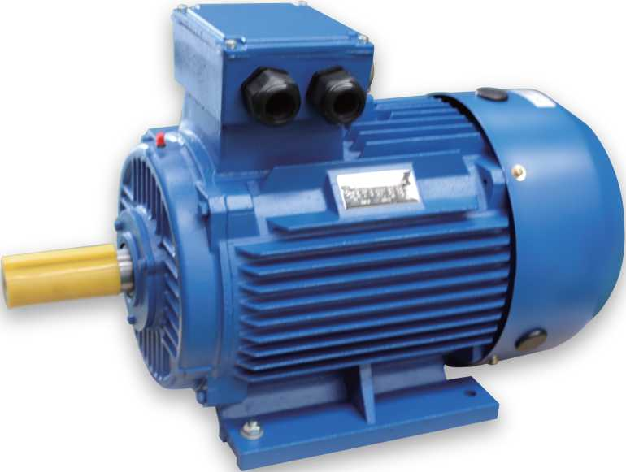

主要性能 Main Performance
•额定功率范围 Rated Power Range:0.07-200KW
•额定频率 Rated Frequency： 50Hz
•额定电压 Rated Voltage: 380V
•电机极数 Motor Poles: 2/4. 2/6、4/6、4/8、6/8、6/12、8/10、4/6/8
•标准防护等级 International Protection Standard: IP54
绝缘系统：
按F级(155P )设计，在额定输出和直接供电时电机温升按80K考核，315机座号 的2、4极以及355机座号的电机温升允许达到105K;在250右环境温度下能正常运行2 小时。
电动机冷却方式：标准冷却方式为IC411. IC410自扇冷，可以是电机N端(非轴伸 端)带风扇，在满足冷却风量情况下可依靠轴伸端驱动的风机带来的风进行冷却；
电机315-355、200及以上2极电机标配带注油嘴，132及以上电机可选配；
铸件材料：铸铁；
标准安装结构类型：IM B3、IM B5、IM B35等；
电机可选用PTC或PT100热敏电阻进行绕组保护，也可加装绕组测温装置，160以上电 机可以选配轴承测温装置；
特殊设计：我公司可根据客户要求设计特殊电压、频率的电机；可根据客户要求调 整电机外观颜色。
Insulation System:
According to the design of class F (155 DEG C), in the rated output and direct power supply motor temperature rise according to 80K appraisal, 315 seat No. 2, 4 pole and 355 frame size motor temperature rise is allowed to reach 105K;
Cooling Method standard cooling mode for IC410, IC411 self fan cooling, can be the motor N end (non shaft extension) with the fan, in order to meet the cooling air flow can rely on shaft extension end driven by the wind turbine cooling;
Motor 315-355, 200 and above 2 pole motor with standard oil nozzles, and more than 132 motor optional;
Material: cast iron castings;
Standard installation structure of: IM B3, IM B5, IM B35 etc.;
The motor can be used PTC or PT100 thermistor for winding protection, but also the installation of winding temperature measuring device, from frame 160 and up motor optional bearing temperature measuring device;
Special design: we can design special motor voltage and frequency according to customer requirements; can be adjusted according to customer requirements of motor appearance color.

DfiANE
电动机/清洗机/自动化 Motor / cleaning machine / Automation
DQANE
电动机/清洗机/自动化 Motor / cleaning machine / Automation
YDT3 series Pole-changing Three Phase Induction Asynchronous Motors

YDT3系列变极多速三相异步电动机

YDT3 series Pole-changing Three Phase Asynchronous Motors

YDT3系列变极多速三相异步电动机

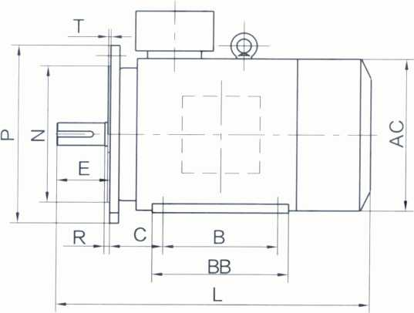
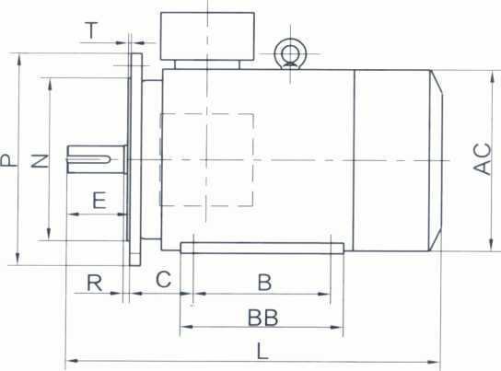
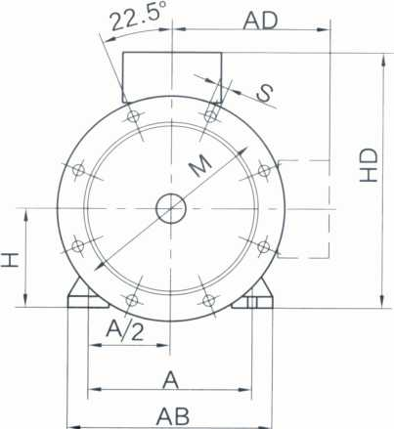
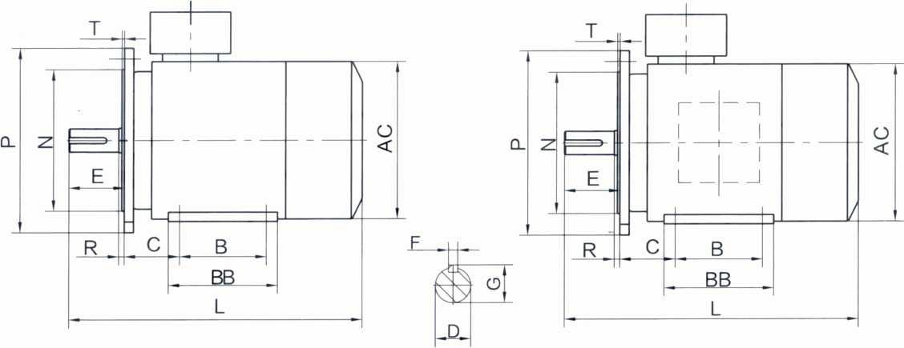
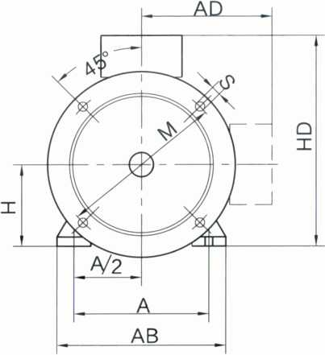

机座号Frame Sizel 00-132
机座号Frame Sizel 60-355
机座号Frame Size225~355
机座号Frame Size63~71
机座号Frame Size80~90
机座号Frame Size63~200

Installation dimensions and tolerances 安装尺寸及公差 |  |  |  |  |  |  |  |  |  |  |  | Configuration dimensions 外形尺寸
K |  | M | N |  | P | R |  | S |  | T |  | AB | AC | BB | HD | L
Basic dimenrsions 基本 尺寸 | Limit deviation 极限 偏差 | M | Basic dimenrsions 基本 尺寸 | Limit deviation 极限 偏差 | P | Basic dimenrsions 基本 尺寸 | Limit deviation 极限 偏差 | Basic dimenrsions 基本 尺寸 | Limit deviation 极限 偏差 | Basic dimenrsions 基本 尺寸 | Limit deviation 极限 偏差
10 | +0.36  0 | 165 | 130 | +0.014  -0.011 | 200 | 0 | ±1.5 | 12 | +0.43  0 | 3.5 | 0  -0.12 | 160 | 155 | 130 | 210 | 285
 |  |  |  |  |  |  |  |  |  |  |  | 175 | 175 | 140 | 236 | 312
 |  |  |  |  |  |  |  |  |  |  |  |  |  | 165 | 236 | 337
12 | +0.43  0 | 215 | 180 | +0.014  -0.011 | 250 | 0 | ±2.0 | 15 | +0.43  0 | 4.0 | 0  -0.12 | 200 | 196 | 175 | 259 | 373
 |  |  |  |  |  |  |  |  |  |  |  | 230 | 219 | 178 | 297 | 393
12 | +0.43  0 | 265 | 230 | +0.016  -0.013 | 300 |  |  |  |  |  |  | 262 | 258 | 185 | 345 | 463
 |  |  |  |  |  |  |  |  |  |  |  |  |  | 224 | 345 | 501
14.5 | +0.43  0 | 300 | 250 | +0.016  -0.013 | 350 | 0 | ±3.0 | 19 | +0.52  0 |  | 0  -0.12 | 314 | 315 | 260 | 414 | 609
 |  |  |  |  |  |  |  |  |  |  |  |  |  | 304 | 414 | 653
 |  |  |  |  |  |  |  |  |  |  |  | 349 | 358 | 310 | 455 | 687
 |  |  |  |  |  |  |  |  |  |  |  |  |  | 349 | 455 | 727
18.5 | +0.43  0 | 350 | 300 | ±0.016 | 400 | 0 | ±4.0 |  |  |  |  | 388 | 400 | 369 | 512 | 760
18.5 | +0.43  0 | 400 | 350 | ±0.018 | 450 |  |  |  |  |  |  | 431 | 448 | 368 | 522 | 802
 |  |  |  |  |  |  |  |  |  |  |  |  |  | 393 | 522 | 797
 |  |  |  |  |  |  |  |  |  |  |  |  |  |  |  | 827
24 | +0.52  0 | 500 | 450 | ± 0.020 | 550 |  |  |  |  |  |  | 484 | 497 | 445 | 609 | 908
 |  |  |  |  |  |  |  |  |  |  |  | 542 | 549 | 485 | 670 | 967
 |  |  |  |  |  |  |  |  |  |  |  |  |  | 536 | 670 | 1028
28 | +0.52  0 | 600 | 550 | ± 0.022 | 660 | 0 | ±4.0 | 24 | +0.52  0 | 6.0 | 0 -0.15 | 635 | 620 | 570 | 852 | 1195
 |  |  |  |  |  |  |  |  |  |  |  |  |  |  |  | 1225
 |  |  |  |  |  |  |  |  |  |  |  |  |  | 680 | 852 | 1299
 |  |  |  |  |  |  |  |  |  |  |  |  |  |  |  | 1329
 |  |  |  |  |  |  |  |  |  |  |  |  |  |  |  | 1299
 |  |  |  |  |  |  |  |  |  |  |  |  |  |  |  | 1329
28 | +0.52  0 | 740 | 680 | ± 0.025 | 800 |  |  |  |  |  |  | 730 | 700 | 750 | 1002 | 1487
 |  |  |  |  |  |  |  |  |  |  |  |  |  |  |  | 1418
 |  |  |  |  |  |  |  |  |  |  |  |  |  |  |  | 1487
 |  |  |  |  |  |  |  |  |  |  |  |  |  |  |  | 1517

Frame size | Pole | Installation dimensions and tolerances 安装尺寸及公差
Frame size | Pole | A | B | C |  | D |  | E |  | F |  | G |  | H
机座号 | 极数 | Basic dimenrsions 基本 尺寸 | Basic dimenrsions 基本 尺寸 | Basic dimenrsions 基本 尺寸 | Limit deviation 极限 偏差 | Basic dimenrsions 基本 尺寸 | Limit deviation 极限 偏差 | Basic dimenrsions 基本 尺寸 | Limit deviation 极限 偏差 | Basic dimenrsions 基本 尺寸 | Limit deviation 极限 偏差 | Basic dimenrsions 基本 尺寸 | Limit deviation 极限 偏差 | Basic dimenrsions 基本 尺寸 | Limit deviation 极限 偏差
80M | 2~8 | 125 | 100 | 50 | ±1.5 | 19 | +0.009  -0.004 | 40 | ±0.31 | 6 | o -0.030 | 15.5 | o -O.O1 | 80 | 0  -0.5
90S | 2~8 | 140 | 100 | 56 | ±1.5 | 24 | +0.009  -0.004 | 50 | ±0.31 | 8 | 0  -0.036 | 20 | 0 -0.02 | 90 | 0  -0.5
90L | 2~8 | 140 | 125
100L | 2~8 | 160 | 140 | 63 | ±2.0 | 28 | +0.009  -0.004 | 60 | ±0.37 | 8 | 0  -0.036 | 24 | 0 -0.02 | 100 | 0  -0.5
112M | 2~8 | 190 | 140 | 70 |  |  |  |  |  |  |  |  |  | 112 | 0  -0.5
132S | 2~8 | 216 | 140 | 89 | ±2.0 | 38 | +0.018  +0.002 | 80 | ±0.37 | 10 | 0  -0.036 | 33 | 0 -0.02 | 132 | 0  -0.5
132M | 2~8 | 216 | 178
160M | 2~8 | 254 | 210 | 108 | ±3.0 | 42 | +0.018  +0.002 | 110 | ±0.43 | 12 | 0 -0.043 | 37 | 0 -0.02 | 160 | 0  -0.5
160L | 2~8 | 254 | 254
180M | 2~8 | 279 | 241 | 121 | ±3.0 | 48 | +0.018  +0.002 | 110 | ±0.43 | 14 | 0 -0.043 | 42.5 | 0 -0.02 | 180 | 0  -0.5
180L | 2~8 | 279 | 279
200L | 2~8 | 318 | 305 | 133 | ±3.0 | 55 | +0.030  +0.011 | 110 | ±0.43 | 16 | 0 -0.043 | 49 | 0 -0.02 | 200 | 0  -0.5
225S | 4~8 | 356 | 286 | 149 | ±4.0 | 60 | +0.030  +0.011 | 140 | ±0.50 | 18 | 0 -0.043 | 53 | 0 -0.02 | 225 | 0  -0.5
225M | 2 | 356 | 311 | 149 | ±4.0 | 55 | +0.030  +0.011 | 110 | ±0.43 | 16 | 0 -0.043 | 49 | 0 -0.02 | 225 | 0  -0.5
225M | 4~8 |  |  |  |  | 60 | +0.030  +0.011 | 140 | ±0.50 | 18 | 0 -0.043 | 53 | 0 -0.02 | 225 | 0  -0.5
250M | 2 | 406 | 349 | 168 |  |  |  |  |  |  |  |  |  | 250 | 0  -0.5
250M | 4~8 |  |  |  |  | 65 |  |  |  |  |  | 58 | 0 -0.02 | 250 | 0  -0.5
280S | 2 | 457 | 368 | 190 |  |  |  |  |  |  |  |  |  | 280 | 0  -1.0
280S | 4~8 |  |  |  |  | 75 | +0.030  +0.011 | 140 | ±0.50 | 20 | o -0.052 | 67.5 | 0 -0.02 | 280 | 0  -1.0
280M | 2 | 457 | 419 | 190 | ±4.0 | 65 | +0.030  +0.011 | 140 | ±0.50 | 18 | o -0.043 | 58 | 0 -0.02 | 280 | 0  -1.0
280M | 4~8 |  |  |  |  | 75 | +0.030  +0.011 | 140 | ±0.50 | 20 | O -0.052 | 67.5 | 0 -0.02 | 280 | 0  -1.0
315S | 2 | 508 | 406 | 216 | ±4.0 | 65 | +0.030  +0.011 | 140 | ±0.50 | 18 | O -0.043 | 58 | 0 -0.02 | 315 | 0  -1.0
315S | 4~10 |  |  |  |  | 80 | +0.030  +0.011 | 170 | ±0.50 | 22 | O -0.052 | 71 | 0 -0.02 | 315 | 0  -1.0
315M | 2 | 508 | 457 | 216 | ±4.0 | 65 | +0.030  +0.011 | 140 | ±0.50 | 18 | O -0.043 | 58 | 0 -0.02 | 315 | 0  -1.0
315M | 4~10 |  |  |  |  | 80 | +0.030  +0.011 | 170 | ±0.50 | 22 | o -0.052 | 71 | 0 -0.02 | 315 | 0  -1.0
315L | 2 | 508 | 508 | 216 | ±4.0 | 65 | +0.030  +0.011 | 140 | ±0.50 | 18 | o -0.043 | 58 | 0 -0.02 | 315 | 0  -1.0
315L | 4~10 |  |  |  |  | 80 | +0.030  +0.011 | 170 | ±0.50 | 22 | 0  -0.052 | 71 | 0 -0.02 | 315 | 0  -1.0
355M | 2 | 610 | 560 | 254 | ±4.0 | 75 | +0.030  +0.011 | 140 | ±0.50 | 20 | 0  -0.052 | 67.5 | 0 -0.02 | 355 | 0  -1.0
355M | 4~10 |  |  |  |  | 95 | +0.035 +0.013 | 170 | ±0.50 | 25 | 0  -0.052 | 86 | 0 -0.02 | 355 | 0  -1.0
355L | 2 | 610 | 630 | 254 | ±4.0 | 75 | +0.030 +O.O1 1 | 140 | ±0.50 | 20 | 0  -0.052 | 67.5 | 0 -0.02 | 355 | 0  -1.0
355L | 4~10 |  |  |  |  | 95 | +0.035 +0.013 | 170 | ±0.50 | 25 | 0  -0.052 | 86 | 0 -0.02 | 355 | 0  -1.0

YDT3 series Pole-changing Three Phase Asynchronous Motors

YDT3系列变极多速三相异步电动机
YDT3 series Pole-changing Three Phase Asynchronous Motors

YDT3系列变极多速三相异步电动机

DQANE
电动机/清洗机/自动化
Motor/cleaning machine / Automation
性能数据 Performance Data
性能数据 Performance Data
 |  |  |  | Power | IN(A) 额定电流 |  | Torque 转矩 |  | Noise 噪声 dB(A) LW/LP
Type 型号 | Power 功率 kW | Speed 转速 r/min | Eff. 效率  % | factor  功率 因素  cos 4) | 额定电流  380V IN(A) | 额定电流 400V IN(A) | 堵转电流 额定电流  IST/IN | 堵转转矩 讎转矩  TST/IN | Noise 噪声 dB(A) LW/LP

2/4极 pole
 |  |  |  | Power | IN(A) 额定电流 |  | Torque 转矩 |  | Noise 噪声 dB(A) LW/LP
Type 型号 | Power 功率 kW | Speed 转速 r/min | Eff. 效率  % | factor 功率 因素 COS。 | 额定电流  380V IN(A) | 额定电流  400V IN(A) | 堵转电流 额定电流  IST/IN | 堵转转矩 额定转矩  TST/TN | Noise 噪声 dB(A) LW/LP

2/6 极 pole
YDT3-71M1-24 | 0.25 | 2800 | 64.0 | 0.81 | 0.73 | 0.69 | 7.5 | 2.0 | 79
YDT3-71M1-24 | 0.07 | 1400 | 57.0 | 0.73 | 0.35 | 0.33 | 5.5 | 1.4 | 79
YDT3-71M2-2/4 | 0.37 | 2800 | 66.0 | 0.82 | 1 | 0.95 | 7.5 | 2.0 | 79
YDT3-71M2-2/4 | 0.10 | 1400 | 58.0 | 0.73 | 0.44 | 0.42 | 5.5 | 1.4 | 79
YDT3-80M0-2^4 | 0.55 | 2820 | 69.0 | 0.82 | 1.42 | 1.35 | 7.5 | 2.0 | 79
YDT3-80M0-2^4 | 0.14 | 1400 | 59.0 | 0.73 | 0.45 | 0.43 | 5.5 | 1.4 | 79
YDT3-80M1-24 | 0.75 | 2840 | 70.0 | 0.82 | 1.9 | 1.8 | 7.5 | 2.0 | 79
YDT3-80M1-24 | 0.17 | 1400 | 64.0 | 0.73 | 0.48 | 0.46 | 5.5 | 1.4 | 79
YDT3-80M2-2/4 | 0.95 | 2840 | 70.0 | 0.82 | 2.4 | 2.3 | 7.5 | 2.0 | 79
YDT3-80M2-2/4 | 0.25 | 1400 | 64.0 | 0.73 | 0.71 | 0.67 | 5.5 | 1.4 | 79
YDT3-90S-2/4 | 1.1 | 2840 | 74.0 | 0.85 | 2.66 | 2.53 | 7.5 | 2.0 | 79
YDT3-90S-2/4 | 0.25 | 1400 | 71.0 | 0.73 | 0.73 | 0.69 | 5.5 | 1.4 | 79
YDT3-90L1-2/4 | 1.4 | 2840 | 75.0 | 0.87 | 3.1 | 2.9 | 7.5 | 2.0 | 83
YDT3-90L1-2/4 | 0.30 | 1400 | 72.0 | 0.73 | 1.45 | 1.38 | 5.5 | 1.4 | 83
YDT3-90L2-2/4 | 1.9 | 2840 | 75.0 | 0.87 | 3.9 | 3.7 | 7.5 | 2.0 | 83
YDT3-90L2-2/4 | 0.40 | 1400 | 72.0 | 0.73 | 1.5 | 1.4 | 5.5 | 1.4 | 83
YDT3-100L1-2/4 | 2.5 | 2880 | 82.0 | 0.87 | 5.3 | 5 | 7.5 | 2.0 | 87
YDT3-100L1-2/4 | 0.65 | 1400 | 76.0 | 0.74 | 1.6 | 1.5 | 5.5 | 1.4 | 87
YDT3-100L2-2/4 | 3.1 | 2880 | 82.0 | 0.87 | 6.4 | 6.1 | 7.5 | 2.0 | 87
YDT3-100L2-2/4 | 0.8 | 1400 | 76.0 | 0.74 | 2 | 1.9 | 5.5 | 1.4 | 87
YDT3-112M-2/4 | 4.4 | 2880 | 82.0 | 0.89 | 8.3 | 7.9 | 7.5 | 2.0 | 87
YDT3-112M-2/4 | 1.1 | 1400 | 80.0 | 0.74 | 3.1 | 2.9 | 5.5 | 1.4 | 87
YDT3-132S-2A1 | 5.9 | 2900 | 83.0 | 0.91 | 11 | 10.5 | 7.5 | 1.9 | 91
YDT3-132S-2A1 | 1.4 | 1440 | 80.0 | 0.77 | 2.9 | 2.8 | 5.5 | 1.3 | 91
YDT3-132M-24 | 8 | 2900 | 85.0 | 0.91 | 15.7 | 14.9 | 7.5 | 1.9 | 91
YDT3-132M-24 | 2 | 1440 | 83.0 | 0.77 | 5.0 | 4.9 | 5.5 | 1.3 | 91
YDT3-160M-2/4 | 12.5 | 2900 | 86.0 | 0.91 | 20.9 | 19.9 | 7.5 | 1.9 | 95
YDT3-160M-2/4 | 2.8 | 1440 | 85.0 | 0.75 | 7.7 | 7.3 | 5.5 | 1.3 | 95
YDT3-160L-2/4 | 16 | 2900 | 87.0 | 0.91 | 29 | 27.6 | 7.5 | 1.9 | 95
YDT3-160L-2/4 | 3.8 | 1440 | 86.0 | 0.76 | 7.8 | 7.4 | 5.5 | 1.3 | 95
YDT3-180M-24 | 18.5 | 2900 | 87.02 | 0.91 | 35 | 33.3 | 7.5 | 1.9 | 96
YDT3-180M-24 | 4.6 | 1440 | 86.0 | 0.75 | 13 | 12.4 | 5.5 | 1.3 | 96
YDT3-180L-2/4 | 22 | 2900 | 87.0 | 0.91 | 41.7 | 39.6 | 7.5 | 1.9 | 96
YDT3-180L-2/4 | 5.5 | 1440 | 86.0 | 0.75 | 16 | 15.2 | 5.5 | 1.3 | 96
YDT3-200L-2/4 | 30 | 2940 | 87.0 | 0.91 | 59 | 56.1 | 7.5 | 1.9 | 98
YDT3-200L-2/4 | 7.5 | 1470 | 86.0 | 0.76 | 17 | 16.2 | 5.5 | 1.3 | 98
YDT3-225S-2^l | 37 | 2940 | 87.0 | 0.91 | 81 | 77 | 7.5 | 1.9 | 99
YDT3-225S-2^l | 9 | 1470 | 86.0 | 0.76 | 20 | 19 | 5.5 | 1.3 | 99

4/6 极 pole
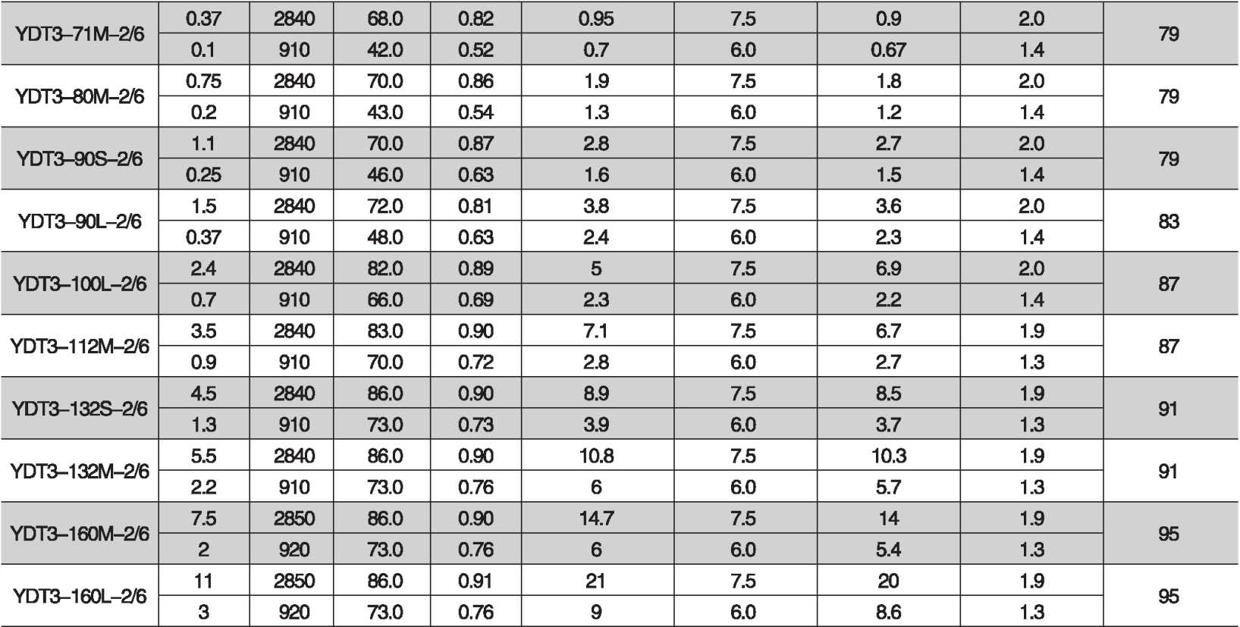
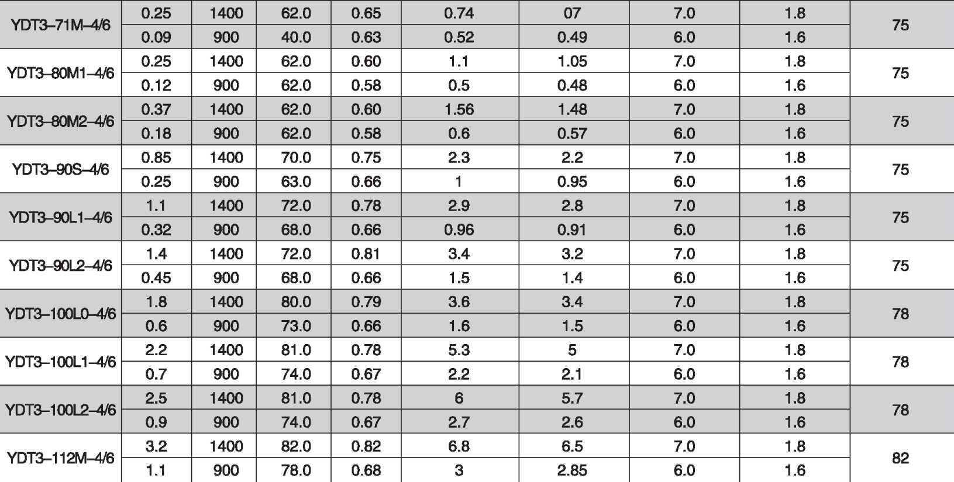

DQANE
电动机/清洗机/自动化
Motor/cleaning machine / Automation
YDT3 series Pole-changing Three Phase Asynchronous Motors

YDT3系列变极多速三相异步电动机

YDT3 series Pole-changing Three Phase Asynchronous Motors

YDT3系列变极多速三相异步电动机

性能数据 Performance Data
性能数据 Performance Data

 |  |  |  | Power | IN(A) 额定电流 |  | Torque 转矩 |  | Noise  噪声 dB(A) LW/LP
Type 型号 | Power 功率 kW | Speed 转速 r/min | Eff. 效率  % | factor 功率 因素 COS。 | 额定电流  380V IN(A) | 额定电流  400V IN(A) | 堵转电流 额定电流  IST/IN | 堵转转矩 麒转矩  TST/TN | Noise  噪声 dB(A) LW/LP
4/6极 pole

 |  |  |  | Power | IN(A) 额定电流 |  | Torque 转矩 |  | Noise 噪声 dB(A) LW/LP
Type 型号 | Power 功率 kW | Speed 转速 r/min | Eff. 效率  % | factor 功率 因素 COS。 | 额定电流  380V IN(A) | 额定电流  400V IN(A) | 堵转电流 额定电流  IST/IN | 堵转转矩 额定转矩  TST7TN | Noise 噪声 dB(A) LW/LP
4/8 极 pole
YDT3-132 J6 | 4.7 | 1440 | 84.0 | 0.83 | 8.7 | 8.3 | 7.0 | 1.8 | 82
YDT3-132 J6 | 1.5 | 940 | 81.0 | 0.68 | 3.2 | 3 | 6.0 | 1.6 | 82
YDT3-132M-4/6 | 6.7 | 1440 | 85.0 | 0.85 | 12.6 | 12 | 7.0 | 1.8 | 82
YDT3-132M-4/6 | 2.2 | 940 | 83.0 | 0.69 | 4.8 | 4.4 | 6.0 | 1.6 | 82
YDT3-160M-4/6 | 9.5 | 1440 | 87.0 | 0.84 | 18.9 | 18 | 7.5 | 1.8 | 86
YDT3-160M-4/6 | 3.1 | 940 | 83.0 | 0.69 | 8 | 7.6 | 7.0 | 1.6 | 86
YDT3-160L-4/6 | 12 | 1440 | 88.0 | 0.84 | 22.6 | 21.5 | 7.5 | 1.8 | 86
YDT3-160L-4/6 | 4 | 940 | 83.0 | 0.73 | 10.5 | 10 | 7.0 | 1.6 | 86
YDT3-180M-4/6 | 15.5 | 1460 | 87.0 | 0.87 | 30.4 | 28.9 | 7.5 | 1.5 | 90
YDT3-180M-4/6 | 5.1 | 960 | 81.0 | 0.77 | 11.4 | 10.8 | 7.0 | 1.5 | 90
YDT3-180L-4/6 | 18 | 1460 | 87.0 | 0.85 | 33 | 31.4 | 7.5 | 1.5 | 90
YDT3-180L-4/6 | 6.2 | 960 | 81.0 | 0.75 | 13 | 12.4 | 7.0 | 1.5 | 90
YDT3-200L1T6 | 22 | 1460 | 88.0 | 0.88 | 42.7 | 40.6 | 7.5 | 1.5 | 90
YDT3-200L1T6 | 8 | 960 | 83.0 | 0.76 | 19 | 18.1 | 7.0 | 1.5 | 90
YDT3-200L2-4/6 | 24 | 1460 | 88.0 | 0.88 | 46.8 | 44.5 | 7.5 | 1.5 | 90
YDT3-200L2-4/6 | 8.5 | 960 | 83.0 | 0.76 | 18.8 | 17.9 | 7.0 | 1.5 | 90
YDT3-225S-4/6 | 33 | 1470 | 89.0 | 0.86 | 66 | 62.7 | 7.5 | 1.5 | 92
YDT3-225S-4/6 | 11 | 970 | 84.0 | 0.84 | 24 | 22.8 | 7.0 | 1.5 | 92
YDT3-225M-^/6 | 38 | 1470 | 90.0 | 0.88 | 73 | 69.4 | 7.5 | 1.5 | 92
YDT3-225M-^/6 | 13 | 970 | 85.0 | 0.86 | 27 | 25.7 | 7.0 | 1.5 | 92
YDT3-250M1-4/6 | 42 | 1470 | 90.0 | 0.90 | 77 | 73.2 | 7.5 | 1.5 | 94
YDT3-250M1-4/6 | 14 | 970 | 85.0 | 0.88 | 30 | 28.5 | 7.0 | 1.5 | 94
 | 47 | 1470 | 90.0 | 0.90 | 87 | 82.7 | 7.5 | 1.5 | 94
YU I o—ZouM^-4/o | 16 | 970 | 85.0 | 0.88 | 32 | 30.4 | 7.0 | 1.5 | 94
YDT3-280J6 | 55 | 1480 | 90.0 | 0.89 | 103 | 97.9 | 7.5 | 1.5 | 94
YDT3-280J6 | 18.5 | 98p | 85.0 | 0.87 | 37 | 35.2 | 7.0 | 1.5 | 94
YDT3-280M1-4/6 | 75 | 1480 | 91.0 | 0.90 | 139 | 132 | 7.5 | 1.5 | 98
YDT3-280M1-4/6 | 25 | 980 | 87.0 | 0.87 | 50 | 47.5 | 7.0 | 1.5 | 98
 | 84 | 1480 | 91.0 | 0.90 | 156 | 148 | 7.5 | 1.5 | 98
YU I O—£2OUM^-4/O | 28 | 980 | 87.0 | 0.87 | 56 | 53.2 | 7.0 | 1.5 | 98
YDT3-315S-^/6 | 95 | 1480 | 91.0 | 0.92 | 165 | 156.8 | 7.5 | 1.5 | 100
YDT3-315S-^/6 | 32 | 980 | 89.0 | 0.80 | 68 | 64.6 | 7.0 | 1.5 | 100
YDT3-315M-4/6 | 115 | 1480 | 92.0 | 0.92 | 197 | 187.2 | 7.5 | 1.5 | 100
YDT3-315M-4/6 | 38 | 980 | 90.3 | 0.80 | 80 | 76 | 7.0 | 1.5 | 100
YDT3-315L1-4/6 | 135 | 1480 | 92.3 | 0.92 | 236 | 296.4 | 7.5 | 1.5 | 100
YDT3-315L1-4/6 | 45 | 980 | 90.0 | 0.80 | 94 | 89.3 | 7.0 | 1.5 | 100
YDT3-315L2-^/6 | 160 | 1480 | 93.0 | 0.92 | 284 | 270 | 7.5 | 1.5 | 100
YDT3-315L2-^/6 | 55 | 980 | 91.0 | 0.77 | 120 | 114 | 7.0 | 1.5 | 100
YDT3-355M-4/6 | 200 | 1480 | 93.0 | 0.92 | 345 | 328 | 7.5 | 1.5 | 102
YDT3-355M-4/6 | 70 | 980 | 91.0 | 0.77 | 138 | 131 | 7.0 | 1.5 | 102

YDT3~80M1 询 | 0.25 | 1400 | 69.0 | 0.68 | 0.81 | 0.77 | 7.0 | 1.9 | 75
YDT3~80M1 询 | 0.07 | 690 | 42.0 | 0.58 | 0.26 | 0.25 | 5.0 | 1.5 | 75
YDT3-80M2-4/8 | 0.37 | 1400 | 70.0 | 0.72 | 1.1 | 1.05 | 7.0 | 1.9 | 75
YDT3-80M2-4/8 | 0.10 | 690 | 42.0 | 0.58 | 0.33 | 0.31 | 5.0 | 1.5 | 75
YDT3-90S-4/8 | 0.75 | 1400 | 70.0 | 0.83 | 2 | 1.9 | 7.0 | 1.9 | 75
YDT3-90S-4/8 | 0.18 | 690 | 55.0 | 0.63 | 0.86 | 0.82 | 5.0 | 1.5 | 75
YDT3-90L1T8 | 1 | 1400 | 70.0 | 0.83 | 2.5 | 2.4 | 7.0 | 1.9 | 75
YDT3-90L1T8 | 0.22 | 690 | 55.0 | 0.63 | 1.0 | 0.95 | 5.0 | 1.5 | 75
YDT3-90L2-4/8 | 1.3 | 1400 | 72.0 | 0.83 | 3.4 | 3.23 | 7.0 | 1.9 | 75
YDT3-90L2-4/8 | 0.3 | 690 | 58.0 | 0.63 | 1.4 | 1.33 | 5.0 | 1.5 | 75
YDT3-100L0-4/8 | 1.1 | 1400 | 80.0 | 0.84 | 2.65 | 2.52 | 7.0 | 1.9 | 78
YDT3-100L0-4/8 | 0.25 | 690 | 65.0 | 0.63 | 1.05 | 1 | 5.0 | 1.5 | 78
YDT3-100L1-4/B | 2 | 1400 | 80.0 | 0.81 | 4.8 | 4.6 | 7.0 | 1.9 | 78
YDT3-100L1-4/B | 0.55 | 690 | 65.0 | 0.61 | 2.3 | 2.2 | 5.0 | 1.5 | 78
YDT3-100L2询 | 2.4 | 1400 | 80.0 | 0.81 | 5.7 | 5.4 | 7.0 | 1.9 | 78
YDT3-100L2询 | 0.65 | 690 | 66.0 | 0.61 | 2.7 | 2.6 | 5.0 | 1.5 | 78
YDT3-112M 询 | 3.2 | 1400 | 83.0 | 0.84 | 7.1 | 6.7 | 7.0 | 1.9 | 82
YDT3-112M 询 | 0.9 | 690 | 71.0 | 0.62 | 3 | 2.85 | 5.0 | 1.5 | 82
YDT3-132S-^8 | 3.2 | 1440 | 84.0 | 0.83 | 7.1 | 6.7 | 7.0 | 2.0 | 82
YDT3-132S-^8 | 0.9 | 700 | 75.0 | 0.62 | 3 | 2.85 | 5.0 | 1.2 | 82
YDT3-132M1-4/8 | 4.5 | 1440 | 85.0 | 0.86 | 9.3 | 8.8 | 7.0 | 2.0 | 82
YDT3-132M1-4/8 | 1.1 | 700 | 78.0 | 0.61 | 3.5 | 3.3 | 5.0 | 1.2 | 82
YDT3-132M2-4/8 | 6.3 | 1440 | 85.0 | 0.86 | 13 | 12.4 | 7.0 | 2.0 | 82
YDT3-132M2-4/8 | 1.5 | 700 | 78.0 | 0.61 | 4.7 | 4.5 | 5.0 | 1.2 | 82
YDT3-160M 询 | 8.9 | 1440 | 85.0 | 0.85 | 15.6 | 14.8 | 7.0 | 2.0 | 86
YDT3-160M 询 | 2 | 700 | 82.0 | 0.67 | 6.3 | 6 | 5.0 | 1.2 | 86
YDT3-160L-4/8 | 12 | 1440 | 86.0 | 0.89 | 21.8 | 20.7 | 7.0 | 2.0 | 86
YDT3-160L-4/8 | 2.7 | 700 | 84.0 | 0.67 | 9.3 | 8.8 | 5.0 | 1.2 | 86
YDT3-180M 询 | 16 | 1460 | 88.0 | 0.85 | 31 | 29.5 | 7.0 | 2.0 | 90
YDT3-180M 询 | 4 | 710 | 84.0 | 0.66 | 10 | 9.5 | 5.0 | 1.2 | 90
YDT3-180LT8 | 19.5 | 1460 | 89.0 | 0.85 | 38 | 36.1 | 7.0 | 2.0 | 90
YDT3-180LT8 | 5 | 710 | 85.0 | 0.68 | 13 | 12.4 | 5.0 | 1.2 | 90
YDT3-200L1 询 | 22 | 1460 | 90.0 | 0.87 | 43 | 40.9 | 7.0 | 2.0 | 90
YDT3-200L1 询 | 5.5 | 710 | 87.0 | 0.67 | 15 | 14.3 | 5.0 | 1.2 | 90
YDT3-200L2-4/8 | 29 | 1460 | 90.0 | 0.87 | 54 | 51.3 | 7.0 | 2.0 | 90
YDT3-200L2-4/8 | 7.5 | 710 | 87.0 | 0.68 | 17.5 | 16.6 | 5.0 | 1.2 | 90
YDT3-225S-^8 | 29 | 1470 | 90.0 | 0.88 | 54 | 51.3 | 7.0 | 2.0 | 92
YDT3-225S-^8 | 7.5 | 720 | 87.0 | 0.64 | 17.5 | 16.6 | 5.0 | 1.3 | 92
YDT3-225MT8 | 40 | 1470 | 91.0 | 0.88 | 76 | 72.2 | 7.0 | 2.0 | 92
YDT3-225MT8 | 9.5 | 720 | 88.0 | 0.64 | 26 | 24.7 | 5.0 | 1.3 | 92

YDT3 series Pole-changing Three Phase Asynchronous Motors

YDT3系列变极多速三相异步电动机
YDT3 series Pole-changing Three Phase Asynchronous Motors

YDT3系列变极多速三相异步电动机

DQANE
电动机/清洗机/自动化
Motor/cleaning machine / Automation
性能数据 Performance Data
性能数据 Performance Data
 |  |  |  | Power | IN(A) 额定电流 |  | Torque 转矩 |  | Noise  噪声 dB(A) LW/LP
Type 型号 | Power 功率 kW | Speed 转速 r/min | Eff. 效率  % | factor 功率 因素 COS。 | 额定电流  380V IN(A) | 额定电流  400V IN(A) | 堵转电流 额定电流  IST/IN | 堵转转矩 醍转矩  TST/TN | Noise  噪声 dB(A) LW/LP

4/8极 pole
 |  |  |  | Power | IN(A) 额定电流 |  | Torque 转矩 |  | Noise 噪声 dB(A) LW/LP
Type 型号 | Power 功率 kW | Speed 转速 r/min | Eff. 效率  % | factor 功率 因素 cos 4) | 额定电流  380V IN(A) | 额定电流  400V IN(A) | 堵转电流 额定电流  IST/IN | 堵转转矩 额定转矩 TST/TN | Noise 噪声 dB(A) LW/LP

6/8 极 pole
YDT3-250M18 | 45 | 1470 | 91.0 | 0.87 | 82 | 77.9 | 7.0 | 2.0 | 94
YDT3-250M18 | 11 | 720 | 88.0 | 0.66 | 28 | 26.6 | 5.0 | 1.3 | 94
YDT3-250M2-4/8 | 52 | 1470 | 91.0 | 0.87 | 95 | 96.3 | 7.0 | 2.0 | 94
YDT3-250M2-4/8 | 14.5 | 720 | 88.0 | 0.66 | 37 | 35.2 | 5.0 | 1.3 | 94
YDT3-280J8 | 55 | 1480 | 91.0 | 0.92 | 100 | 95 | 7.0 | 2.0 | 98
YDT3-280J8 | 15 | 730 | 89.0 | 0.82 | 38 | 36.1 | 5.0 | 1.3 | 98
YDT3-280M18 | 65 | 1480 | 91.0 | 0.92 | 118 | 112.1 | 7.0 | 2.0 | 98
YDT3-280M18 | 17 | 730 | 90.0 | 0.79 | 37 | 35.2 | 5.0 | 1.3 | 98
YDT3-280M2-4/8 | 75 | 1480 | 91.0 | 0.92 | 136 | 129.2 | 7.0 | 2.0 | 98
YDT3-280M2-4/8 | 18.5 | 730 | 90.0 | 0.79 | 40 | 38 | 5.0 | 1.3 | 98
YDT3~315 J8 | 92 | 1480 | 91.0 | 0.93 | 165 | 157 | 7.0 | 2.0 | 100
YDT3~315 J8 | 25 | 730 | 90.0 | 0.82 | 51 | 48.5 | 5.0 | 1.3 | 100
YDT3-315M-4^ | 110 | 1480 | 92.0 | 0.93 | 195 | 185.3 | 7.0 | 2.0 | 100
YDT3-315M-4^ | 30 | 730 | 91.0 | 0.82 | 61 | 58 | 5.0 | 1.3 | 100
YDT3-315L1-4^8 | 135 | 1480 | 92.0 | 0.93 | 240 | 228 | 7.0 | 2.0 | 100
YDT3-315L1-4^8 | 36 | 730 | 91.0 | 0.82 | 73 | 68.4 | 5.0 | 1.3 | 100
YDT3-315L2-^8 | 155 | 1480 | 92.0 | 0.93 | 275 | 261.3 | 7.0 | 2.0 | 100
YDT3-315L2-^8 | 41 | 730 | 91.0 | 0.82 | 83 | 78.9 | 5.0 | 1.3 | 100
6/12 极 pole
YDT3-90L-6/12 | 0.37 | 910 | 64.0 | 0.68 | 1.1 | 1.05 | 7.0 | 1.8 | 73
YDT3-90L-6/12 | 0.09 | 450 | 50.0 | 0.50 | 0.5 | 0.48 | 6.0 | 1.3 | 73
YDT3-100L1-6/12 | 0.55 | 910 | 65.0 | 0.71 | 1.6 | 1.52 | 7.0 | 1.8 | 73
YDT3-100L1-6/12 | 0.12 | 450 | 51.0 | 0.53 | 0.6 | 0.57 | 6.0 | 1.3 | 73
YDT3-100L2-6/12 | 0.75 | 910 | 68.0 | 0.71 | 2.1 | 2 | 7.0 | 1.8 | 73
YDT3-100L2-6/12 | 0.18 | 450 | 55.0 | 0.55 | 0.75 | 0.71 | 6.0 | 1.3 | 73
YDT3-112M-6/12 | 1.1 | 930 | 69.0 | 0.73 | 3 | 2.85 | 7.0 | 1.8 | 75
YDT3-112M-6/12 | 0.25 | 460 | 56.0 | 0.58 | 1 | 0.95 | 6.0 | 1.3 | 75
YDT3-132S-6/12 | 2.2 | 930 | 75.0 | 0.75 | 5.9 | 5.6 | 7.0 | 1.8 | 79
YDT3-132S-6/12 | 0.55 | 460 | 60.0 | 0.60 | 2 | 1.9 | 6.0 | 1.3 | 79
YDT3-132M-6/12 | 4.5 | 930 | 77.0 | 0.76 | 11.7 | 11.11 | 7.0 | 1.8 | 79
YDT3-132M-6/12 | 1.5 | 460 | 65.0 | 0.65 | 5.4 | 5.1 | 6.0 | 1.3 | 79
YDT3-160M-6/12 | 5.5 | 930 | 79.0 | 0.78 | 13 | 12.4 | 7.0 | 1.5 | 83
YDT3-160M-6/12 | 1.7 | 460 | 65.0 | 0.60 | 6 | 5.7 | 6.0 | 1.3 | 83
YDT3-160L-6/12 | 7.5 | 930 | 81.0 | 0.80 | 14.9 | 14.2 | 7.0 | 1.5 | 83
YDT3-160L-6/12 | 1.9 | 460 | 65.0 | 0.61 | 6.8 | 6.5 | 6.0 | 1.3 | 83
YDT3-180L-6/12 | 11 | 940 | 83.0 | 0.81 | 23 | 21.9 | 7.0 | 1.5 | 86
YDT3-180L-6/12 | 27 | 470 | 66.0 | 0.61 | 11 | 10.5 | 6.0 | 1.3 | 86
YDT3-200L-6/12 | 22 | 940 | 89.0 | 0.83 | 45 | 42.8 | 7.0 | 1.5 | 88
YDT3-200L-6/12 | 5.5 | 470 | 62.0 | 0.62 | 22 | 20.9 | 6.0 | 1.3 | 88

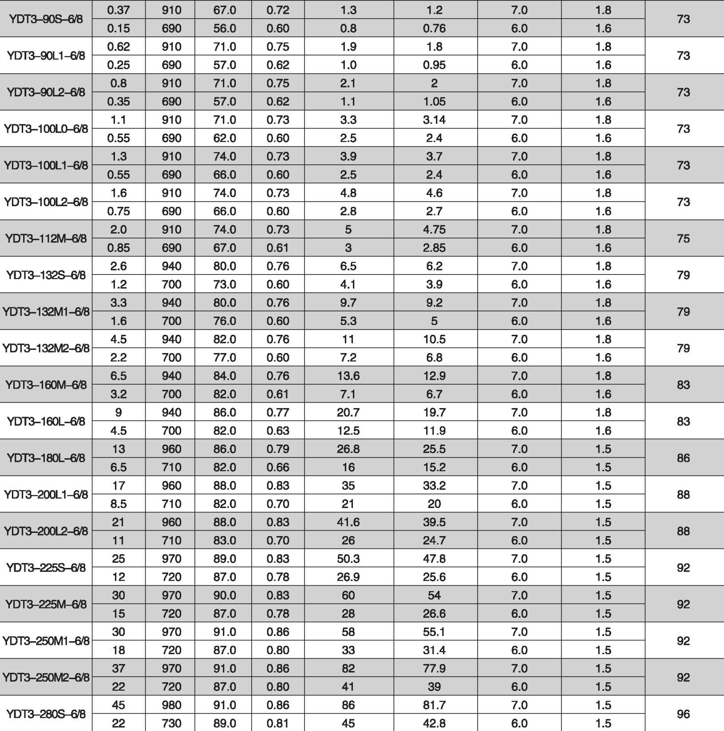

YDT3 series Pole-changing Three Phase Asynchronous Motors

YDT3系列变极多速三相异步电动机
YDT3 series Pole-changing Three Phase Asynchronous Motors

YDT3系列变极多速三相异步电动机

DQANE
电动机/清洗机/自动化
Motor/cleaning machine / Automation
性能数据 Performance Data
性能数据 Performance Data
 |  |  |  | Power | IN(A) 额定电流 |  | Torque 转矩 |  | Noise 噪声 dB(A) LW/LP
Type 型号 | Power 功率 kW | Speed 转速 r/min | Eff. 效率 % | factor 功率 因素 COS。 | 额定电流  380V IN(A) | 额定电流  400V IN(A) | 堵转电流 额定电流  IST/IN | 堵转转矩 麒转矩  TST/TN | Noise 噪声 dB(A) LW/LP

6/8极 pole
 |  |  |  | Power | IN(A) 额定电流 |  | Torque 转矩 |  | Noise 噪声 dB(A) LW/LP
Type 型号 | Power 功率 kW | Speed 转速 r/min | Eff. 效率  % | factor 功率 因素 COS。 | 额定电流  380V IN(A) | 额定电流  400V IN(A) | 堵转电流 额定电流  IST/IN | 堵转转矩 额定转矩  TST7TN | Noise 噪声 dB(A) LW/LP

8/10极 pole
YDT3-280M1-6/B | 55 | 980 | 91.0 | 0.86 | 105 | 99.8 | 7.0 | 1.5 | 96
YDT3-280M1-6/B | 28 | 730 | 89.0 | 0.81 | 57 | 54.2 | 6.0 | 1.5 | 96
YDT3-280M2-6/8 | 65 | 980 | 91.0 | 0.86 | 124 | 118 | 7.0 | 1.5 | 96
YDT3-280M2-6/8 | 32 | 730 | 89.0 | 0.81 | 65 | 61.8 | 6.0 | 1.5 | 96
YDT3-315S-6^8 | 75 | 980 | 91.0 | 0.84 | 145 | 138 | 7.0 | 1.5 | 100
YDT3-315S-6^8 | 37 | 730 | 90.0 | 0.78 | 89 | 85 | 6.0 | 1.5 | 100
YDT3-315M-6« | 90 | 980 | 92.0 | 0.85 | 173 | 164 | 7.0 | 1.5 | 100
YDT3-315M-6« | 45 | 730 | 91.0 | 0.80 | 108 | 103 | 6.0 | 1.5 | 100
YDT3-315L1-6/8 | 110 | 980 | 92.0 | 0.85 | 204 | 194 | 7.0 | 1.5 | 100
YDT3-315L1-6/8 | 55 | 730 | 91.0 | 0.78 | 113 | 107 | 6.0 | 1.5 | 100
YDT3-315L2-68 | 132 | 980 | 92.0 | 0.85 | 239 | 227 | 7.0 | 1.5 | 100
YDT3-315L2-68 | 66 | 730 | 91.0 | 0.78 | 132 | 125 | 6.0 | 1.5 | 100
YDT3-355M1-6/B | 132 | 980 | 92.0 | 0.85 | 239 | 227 | 7.0 | 1.5 | 102
YDT3-355M1-6/B | 66 | 730 | 91.0 | 0.80 | 132 | 125 | 6.0 | 1.5 | 102
YDT3-355M2-6/8 | 160 | 980 | 92.0 | 0.85 | 287 | 273 | 7.0 | 1.5 | 102
YDT3-355M2-6/8 | 80 | 730 | 91.0 | 0.80 | 165 | 157 | 6.0 | 1.5 | 102
YDT3-355L-6/8 | 185 | 980 | 92.0 | 0.85 | 332 | 315 | 7.0 | 1.5 | 102
YDT3-355L-6/8 | 90 | 730 | 91.0 | 0.80 | 186 | 177 | 6.0 | 1.5 | 102
8/10 极 pole
YDT3-90L-fi/10 | 0.37 | 690 | 59.0 | 0.60 | 1.3 | 1.2 | 6.0 | 1.6 | 73
YDT3-90L-fi/10 | 0.18 | 560 | 45.0 | 0.49 | 1.1 | 1.05 | 5.5 | 1.3 | 73
YDT3-100L1-8/10 | 0.55 | 700 | 61.0 | 0.60 | 1.9 | 1.8 | 6.0 | 1.6 | 73
YDT3-100L1-8/10 | 0.25 | 560 | 48.0 | 0.49 | 1.5 | 1.4 | 5.5 | 1.3 | 73
YDT3-100L2-8/10 | 0.75 | 700 | 62.0 | 0.60 | 2.6 | 2.5 | 6.0 | 1.6 | 73
YDT3-100L2-8/10 | 0.37 | 560 | 48.0 | 0.49 | 2.1 | 2 | 5.5 | 1.3 | 73
YDT3-112M-8/10 | 1 1 | 700 | 62.0 | 0.63 | 3.7 | 3.5 | 6.0 | 1.6 | 75
YDT3-112M-8/10 | 0.55 | 560 | 48.0 | 0.52 | 3 | 2.85 | 5.5 | 1.3 | 75
YDT3-132S-8/10 | 1.5 | 700 | 68.0 | 0.65 | 5 | 4.75 | 6.0 | 1.6 | 79
YDT3-132S-8/10 | 0.65 | 570 | 51.0 | 0.53 | 3.5 | 3.3 | 5.5 | 1.3 | 79
YDT3-132M1-8H0 | 1.8 | 700 | 70.0 | 0.66 | 5.9 | 5.6 | 6.0 | 1.6 | 79
YDT3-132M1-8H0 | 0.75 | 570 | 55.0 | 0.53 | 3.9 | 3.7 | 5.5 | 1.3 | 79
YDT3-132M2-8H0 | 2.2 | 700 | 70.0 | 0.65 | 7.3 | 6.9 | 6.0 | 1.6 | 79
YDT3-132M2-8H0 | 1.1 | 570 | 59.0 | 0.60 | 4.5 | 4.3 | 5.5 | 1.3 | 79
YDT3-160M-8/10 | 3 | 700 | 76.0 | 0.68 | 8.8 | 8.4 | 6.0 | 1.8 | 83
YDT3-160M-8/10 | 1.5 | 570 | 72.0 | 0.60 | 5.3 | 5 | 5.5 | 1.4 | 83
YDT3-160L-8/10 | 5.5 | 700 | 80.0 | 0.74 | 14 | 13.3 | 6.0 | 1.8 | 83
YDT3-160L-8/10 | 3 | 570 | 75.0 | 0.67 | 9 | 8.6 | 5.5 | 1.4 | 83
YDT3-180L-8/10 | 7.5 | 710 | 81.0 | 0.80 | 16.5 | 15.7 | 6.0 | 1.8 | 86
YDT3-180L-8/10 | 4 | 570 | 76.0 | 0.65 | 11.8 | 11.2 | 5.5 | 1.4 | 86
YDT3-200L-8/10 | 11 | 710 | 83.0 | 0.83 | 24 | 22.8 | 6.0 | 1.8 | 88
YDT3-200L-8/10 | 5.5 | 570 | 80.0 | 0.66 | 16 | 15.2 | 5.5 | 1.4 | 88

4/6/8极 pole
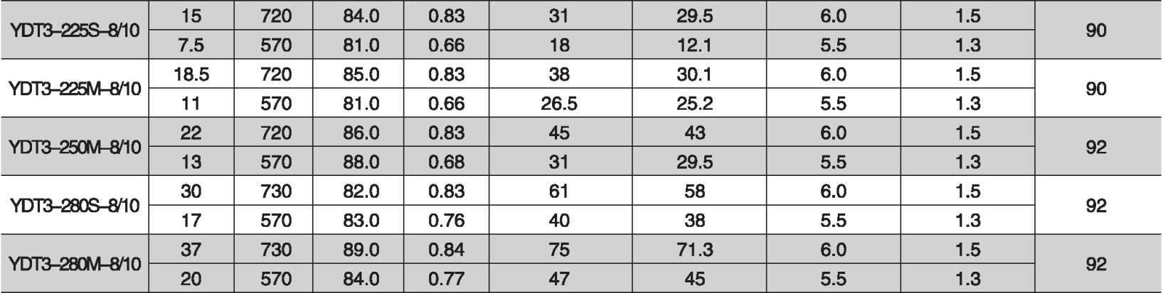
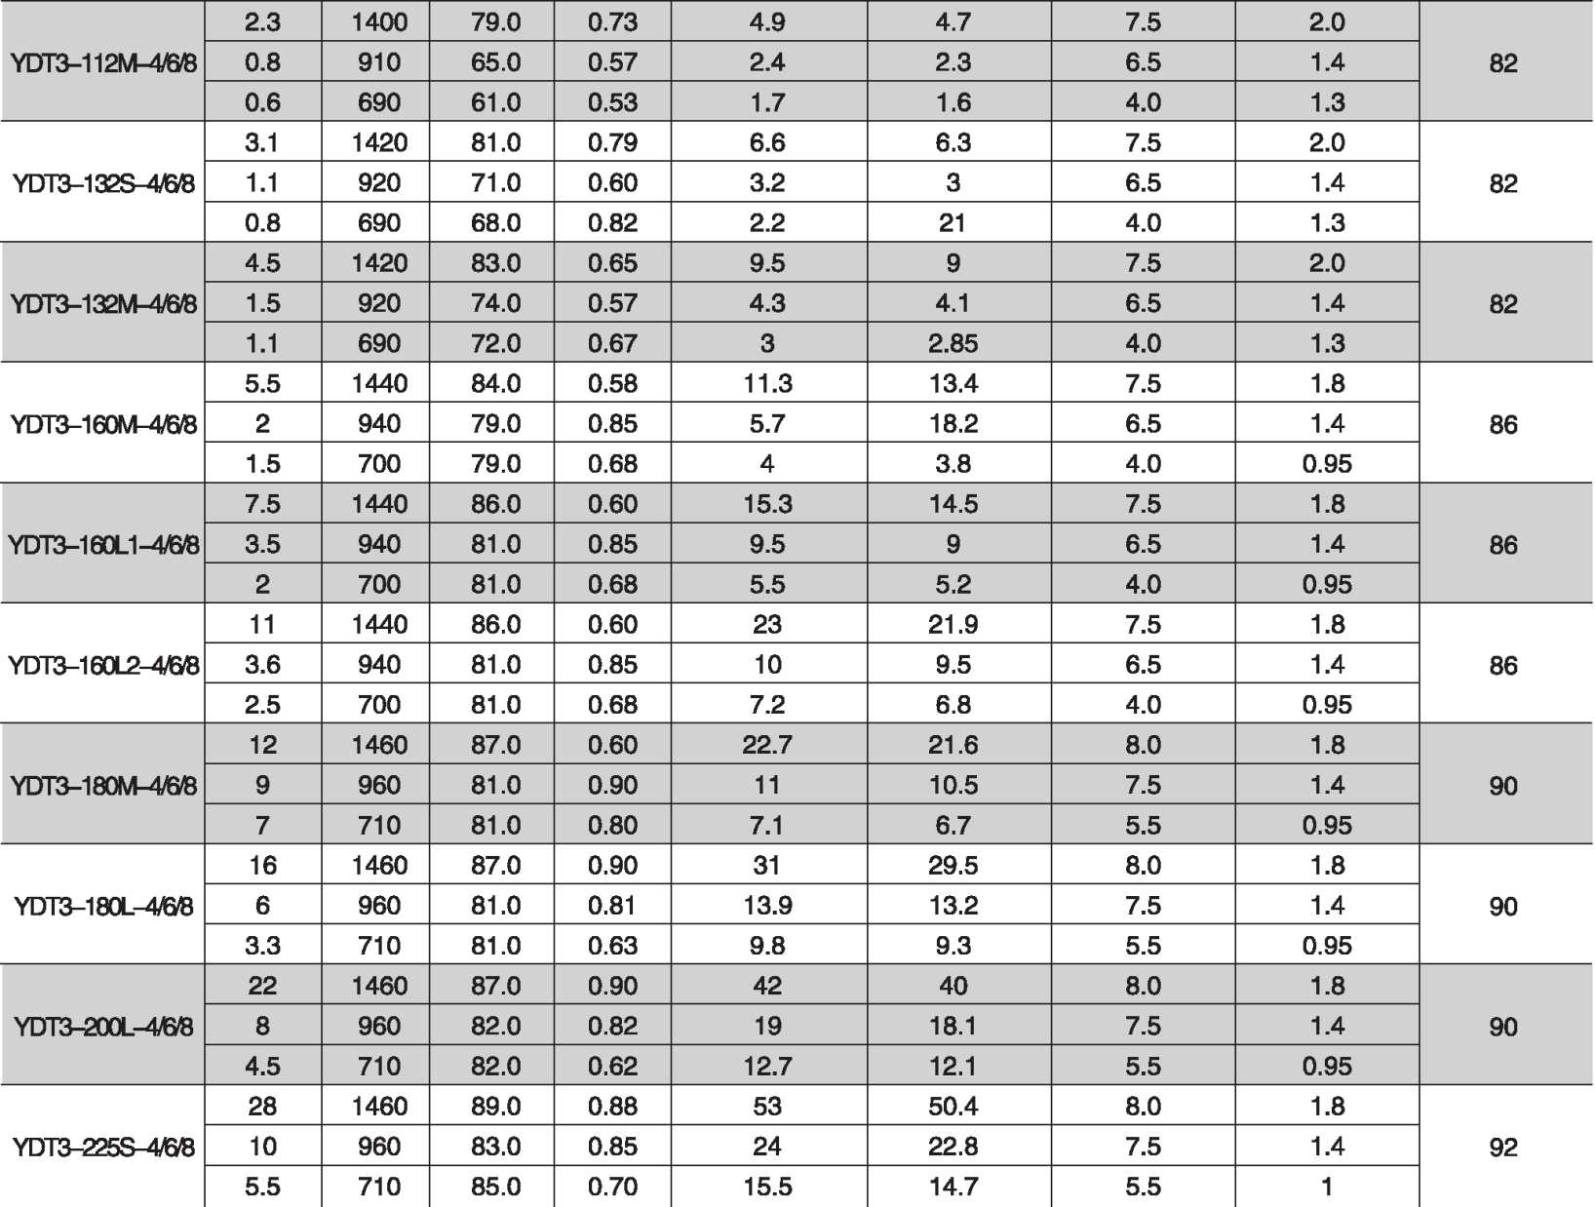

YDT3 series Pole-changing Three Phase Asynchronous Motors

YDT3系列变极多速三相异步电动机
YDT3 series Pole-changing Three Phase Asynchronous Motors

YDT3系列变极多速三相异步电动机

DQANE
电动机/清洗机/自动化
Motor/cleaning machine / Automation
性能数据 Performance Data
性能数据 Performance Data
 |  |  |  | Power | IN(A) 额定电流 |  | Torque 转矩 |  | Noise 噪声 dB(A) LW/LP
體 | Power 功率 kW | Speed 转速 r/min | Eff. 效率  % | factor  功率 因素 cos 4) | 额定电流  380V IN(A) | 额定电流  400V IN(A) | 堵转电流 额定电流  IST/IN | 堵转转矩 额定转矩 TST/TN | Noise 噪声 dB(A) LW/LP

4/6/8极 pole
 |  |  |  | Power | IN(A) 额定电流 |  | Torque 转矩 |  | Noise 噪声 dB(A) LW/LP
Type 型号 | Power 功率 kW | Speed 转速 r/min | Eff. 效率  % | factor 功率 因素 COS。 | 额定电流  380V IN(A) | 额定电流  400V IN(A) | 堵转电流 额定电流  IST/IN | 堵转转矩 额定转矩  TST7TN | Noise 噪声 dB(A) LW/LP

8/10极 pole
YDT3-225S-8/10 | 15 | 720 | 84.0 | 0.83 | 31 | 29.5 | 6.0 | 1.5 | 90
YDT3-225S-8/10 | 7.5 | 570 | 81.0 | 0.66 | 18 | 12.1 | 5.5 | 1.3 | 90
YDT3-225M-8^10 | 18.5 | 720 | 85.0 | 0.83 | 38 | 30.1 | 6.0 | 1.5 | 90
YDT3-225M-8^10 | 11 | 570 | 81.0 | 0.66 | 26.5 | 25.2 | 5.5 | 1.3 | 90
YDT3-250M-8/10 | 22 | 720 | 86.0 | 0.83 | 45 | 43 | 6.0 | 1.5 | 92
YDT3-250M-8/10 | 13 | 570 | 88.0 | 0.68 | 31 | 29.5 | 5.5 | 1.3 | 92
YDT3-280S-8/10 | 30 | 730 | 82.0 | 0.83 | 61 | 58 | 6.0 | 1.5 | 92
YDT3-280S-8/10 | 17 | 570 | 83.0 | 0.76 | 40 | 38 | 5.5 | 1.3 | 92
YDT3-280M-8^10 | 37 | 730 | 89.0 | 0.84 | 75 | 71.3 | 6.0 | 1.5 | 92
YDT3-280M-8^10 | 20 | 570 | 84.0 | 0.77 | 47 | 45 | 5.5 | 1.3 | 92
4/6/8极 pole
YDT3-112M-4/6/8 | 2.3 | 1400 | 79.0 | 0.73 | 4.9 | 4.7 | 7.5 | 2.0 | 82
YDT3-112M-4/6/8 | 0.8 | 910 | 65.0 | 0.57 | 2.4 | 2.3 | 6.5 | 1.4 | 82
YDT3-112M-4/6/8 | 0.6 | 690 | 61.0 | 0.53 | 1.7 | 1.6 | 4.0 | 1.3 | 82
YDT3-132S-4/6/8 | 3.1 | 1420 | 81.0 | 0.79 | 6.6 | 6.3 | 7.5 | 2.0 | 82
YDT3-132S-4/6/8 | 1.1 | 920 | 71.0 | 0.60 | 3.2 | 3 | 6.5 | 1.4 | 82
YDT3-132S-4/6/8 | 0.8 | 690 | 68.0 | 0.82 | 2.2 | 21 | 4.0 | 1.3 | 82
YDT3-132M-4/6/8 | 4.5 | 1420 | 83.0 | 0.65 | 9.5 | 9 | 7.5 | 2.0 | 82
YDT3-132M-4/6/8 | 1.5 | 920 | 74.0 | 0.57 | 4.3 | 4.1 | 6.5 | 1.4 | 82
YDT3-132M-4/6/8 | 1.1 | 690 | 72.0 | 0.67 | 3 | 2.85 | 4.0 | 1.3 | 82
YDT3-160M-4/6/B | 5.5 | 1440 | 84.0 | 0.58 | 11.3 | 13.4 | 7.5 | 1.8 | 86
YDT3-160M-4/6/B | 2 | 940 | 79.0 | 0.85 | 5.7 | 18.2 | 6.5 | 1.4 | 86
YDT3-160M-4/6/B | 1.5 | 700 | 79.0 | 0.68 | 4 | 3.8 | 4.0 | 0.95 | 86
YDT3-160L1-4/6/8 | 7.5 | 1440 | 86.0 | 0.60 | 15.3 | 14.5 | 7.5 | 1.8 | 86
YDT3-160L1-4/6/8 | 3.5 | 940 | 81.0 | 0.85 | 9.5 | 9 | 6.5 | 1.4 | 86
YDT3-160L1-4/6/8 | 2 | 700 | 81.0 | 0.68 | 5.5 | 5.2 | 4.0 | 0.95 | 86
YDT3-160L2-4/6/8 | 11 | 1440 | 86.0 | 0.60 | 23 | 21.9 | 7.5 | 1.8 | 86
YDT3-160L2-4/6/8 | 3.6 | 940 | 81.0 | 0.85 | 10 | 9.5 | 6.5 | 1.4 | 86
YDT3-160L2-4/6/8 | 2.5 | 700 | 81.0 | 0.68 | 7.2 | 6.8 | 4.0 | 0.95 | 86
YDT3-180M-4/6/8 | 12 | 1460 | 87.0 | 0.60 | 22.7 | 21.6 | 8.0 | 1.8 | 90
YDT3-180M-4/6/8 | 9 | 960 | 81.0 | 0.90 | 11 | 10.5 | 7.5 | 1.4 | 90
YDT3-180M-4/6/8 | 7 | 710 | 81.0 | 0.80 | 7.1 | 6.7 | 5.5 | 0.95 | 90
YDT3-180L-4/6® | 16 | 1460 | 87.0 | 0.90 | 31 | 29.5 | 8.0 | 1.8 | 90
YDT3-180L-4/6® | 6 | 960 | 81.0 | 0.81 | 13.9 | 13.2 | 7.5 | 1.4 | 90
YDT3-180L-4/6® | 3.3 | 710 | 81.0 | 0.63 | 9.8 | 9.3 | 5.5 | 0.95 | 90
YDT3-200L-4/6® | 22 | 1460 | 87.0 | 0.90 | 42 | 40 | 8.0 | 1.8 | 90
YDT3-200L-4/6® | 8 | 960 | 82.0 | 0.82 | 19 | 18.1 | 7.5 | 1.4 | 90
YDT3-200L-4/6® | 4.5 | 710 | 82.0 | 0.62 | 12.7 | 12.1 | 5.5 | 0.95 | 90
YDT3-225S-4/6/8 | 28 | 1460 | 89.0 | 0.88 | 53 | 50.4 | 8.0 | 1.8 | 92
YDT3-225S-4/6/8 | 10 | 960 | 83.0 | 0.85 | 24 | 22.8 | 7.5 | 1.4 | 92
YDT3-225S-4/6/8 | 5.5 | 710 | 85.0 | 0.70 | 15.5 | 14.7 | 5.5 | 1 | 92

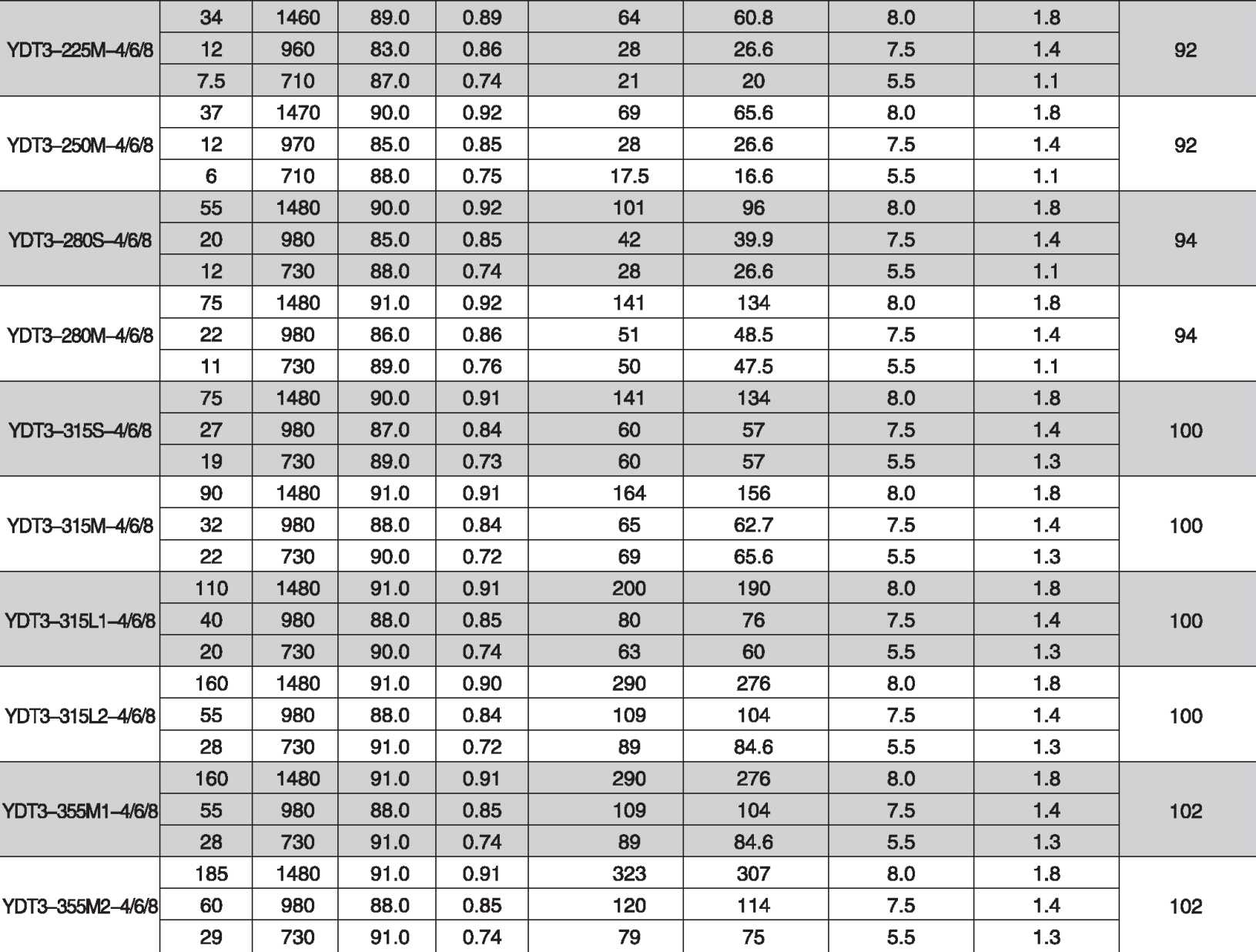

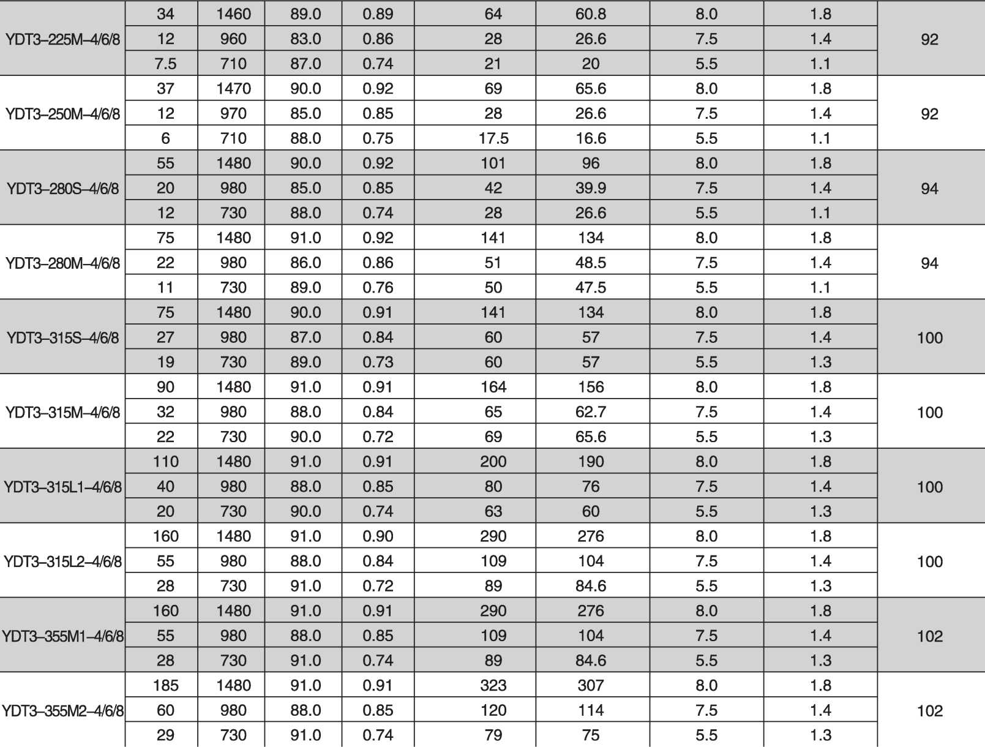
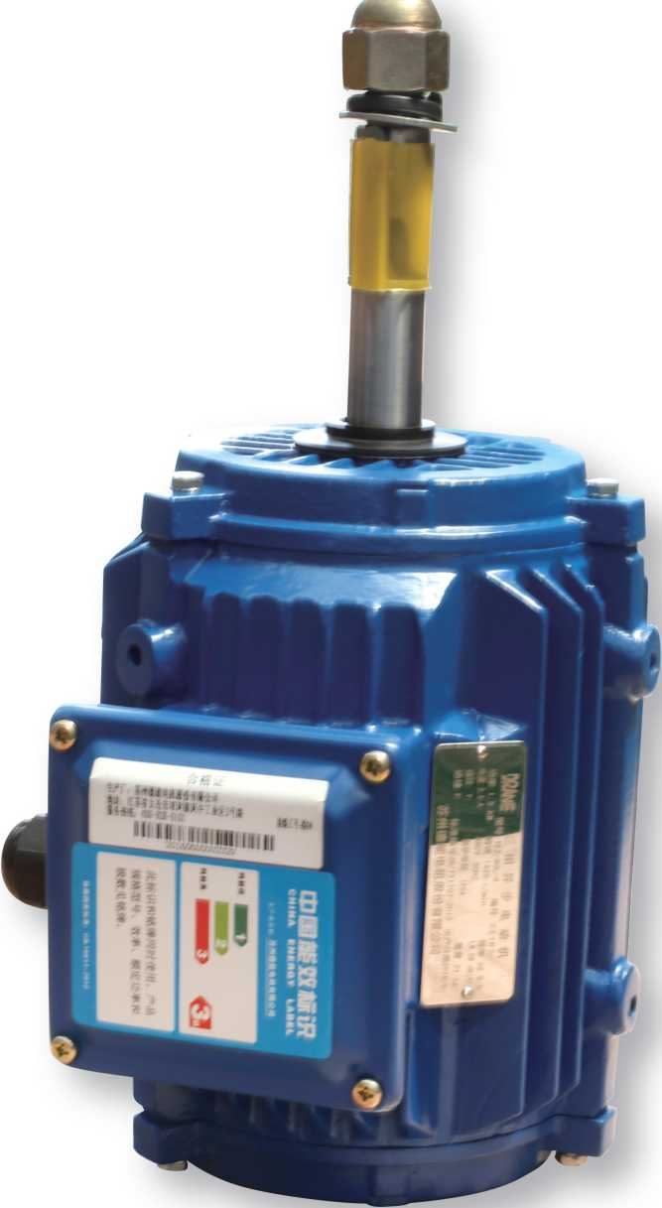

DSkNE
电动机/清洗机/自动化
Motor / cleaning machine / Automation
性能数据 Performance Data
 |  |  |  | Power | IN(A) 额定电流 |  | Torque 转矩 |  | Noise 噪声 dB(A) LW/LP
Type 型号 | Power 功率 kW | Speed 转速 r/min | Eff.  效率 % | factor 功率 因素 COS。 | 额定电流  380V IN(A) | 额定电流  400V IN(A) | 堵转电流 额定电流  IST/IN | 堵转转矩 额定转矩  TST/TN | Noise 噪声 dB(A) LW/LP

4/6/8极 pole
DQhNE
电动机/清洗机/自动化 Motor / cleaning machine / Automation
YDT3 series Pole-changing Three Phase Asynchronous Motors

YDT3系列变极多速三相异步电动机

YCL3 series cooling tower dedicated three-phase asynchronous motor

YCL3冷却塔专用三相异步电动机
YCL3系列冷却塔专用三相异步电动机是由我公司自主研发的一款全封闭、自扇冷、 连续工作制的单速电动机。电机充分考虑到冷却塔的负载特性、使用环境，采用先进的 设计理念；成熟、精密的加工工艺；优质高端的原材料，具有结构紧凑、能效高、噪声 低、振动小、运转平稳可靠、使用寿命长等特点。作为驱动设备应用于冷却塔设备上。
YCL3 series cooling tower dedicated three-phase asynchronous motor is developed by our company independently of a fully enclosed, self fan cooling, continuous working system of single speed motor. Motor give full consideration to the cooling tower load characteristics, the use of the environment, using advanced design concepts; mature, precision processing technology; high quality raw materials, with compact structure, high efficiency, low noise, small vibration, stable and reliable operation, long life and other characteristics. As a driving device for cooling tower equipment.

DQANE
电动机/清洗机/自动化
Motor / cleaning machine / Automation
D站NE
电动机/清洗机/自动化
Motor / cleaning machine / Automation
YCL3 series cooling tower dedicated three-phase asynchronous motor
YCL3冷却塔专用三相异步电动机

YCL3 series cooling tower dedicated three-phase asynchronous motor
YCL3冷却塔专用三相异步电动机

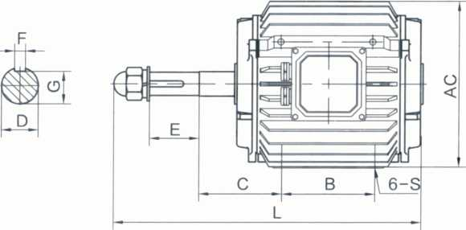
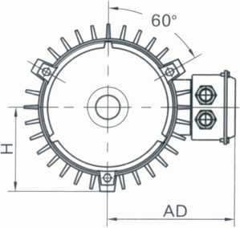
Frame size | Installation dimensions and tolerances 安装尺寸及公差 |  |  |  |  |  |  |  |  |  |  | Configur 夕 |  | ation dimensions 卜形尺寸
Frame size | B | C |  | D |  | E |  | F |  | G |  | S | H | AC | AD | L
机座  a | Basic dimenrsions 基本 尺寸 | Basic dimenrsions 基本  I尺寸I | Limit deviation 极限 I偏差 | 爵  d | Limit deviation 极限 I偏差I | Basic dimenrsions 基本  I尺寸 | Limit deviation 极限 偏差 | Basic dimenrsions 基本  I尺寸I | Limit deviation 极限 I偏差 | 毒  d | Limit deviation 极限 偏差
80M | 80 | 112 | ±1.5 | 19 | +0.009  -0.004 | 40 | ±0.31 | 6 | —0.030 | 15.5 |  | M8 | 79 | 158 | 150 | 321
90S | 90 | 106 | ±1.5 | 24 | +0.009  -0.004 | 50 | ±0.31 | 8 | 0 -0.036 | 20 | o%o | M8 | 85 | 170 | 155 | 344
90L | 110 | 108 |  |  |  |  |  |  |  |  |  |  |  |  |  | 369
100L | 110 | 113 | ±2.0 | 28 | +0.009  -0.004 | 60 | ±0.37 | 8 | 0 -0.036 | 24 | o%o | M10 | 102.5 | 205 | 180 | 400
112M | 110 | 120 |  |  |  |  |  |  |  |  |  | M12 | 115 | 230 | 190 | 419
132S | 150 | 134 | ±2.0 | 38 | +0.018  -0.002 | 80 | ±0.37 | 10 | 0 -0.036 | 33 | o%o | M12 | 135 | 270 | 210 | 496
132M | 150 | 153 |  |  |  |  |  |  |  |  |  |  |  |  |  | 539
160M | 150 | 188 | ±3.0 | 42 | +0.018  -0.002 | 110 | ±0.43 | 12 | 0  -0.043 | 37 | o%o | M16 | 162.5 | 325 | 255 | 626
160L | 150 | 210 |  |  |  |  |  |  |  |  |  |  |  |  |  | 670

安装与外形尺寸 Installation and configuration dimensions
主要性能 Main Performance
•额定功率范围 Rated Power Range:0.18-18.5KW
•额定频率 Rated Frequency： 50Hz
•额定电压 Rated Voltage: 380V
•电机极数 Motor Poles: 2_{S} 4、6、8、10、12、16
•标准防护等级 International Protection Standard： IP54、IP55
绝缘系统：
按F级(155P )设计，在额定输出和直接供电时电机温升按80K考核；
电动机冷却方式：标准冷却方式为IC410自扇冷，依靠冷却塔冷却风进行冷却； 铸件材料：铸铁；
标准安装结构类型：IMV30. IMV1等；
电机可选用PTC或PT100热敏电阻进行绕组保护，也可加装绕组测温装置，〔60以上 电机可以选配轴承测温装置；
特殊设计：我公司可根据客户要求设计特殊电压、频率的电机；可根据客户要求 调整电机外观颜色，根据客户要求设计V1安装。
Insulation System:
According to the design of class F (155 DEG C), in the rated output and direct power supply motor temperature rise according to 80K appraisal;
Cooling Method:standard cooling mode for IC410 self fan cooling, cooling by cooling tower;
Material: cast iron castings;
Standard installation structure of: IMV30、IM V1 etc.;
The motor can be used PTC or PT100 thermistor for winding protection, but also the installation of winding temperature measuring device, from frame 160 and up motor optional bearing temperature measuring device;
Special design:we can design special motor voltage and frequency according to customer requirements; can be adjusted according to customer requirements of motor appearance color. Design V1 installation according to customer's requirement.

。站ME
电动枷清洗枷自动化 Motor/cleaning machine / Automation
DQANE
电动机/清洗机/自动化
Motor / cleaning machine / Automation
YCL3 series cooling tower dedicated three-phase asynchronous motor

YCL3冷却塔专用三相异步电动机

YCL3 series cooling tower dedicated three-phase asynchronous motor

YCL3冷却塔专用三相异步电动机

性能数据 Performance Data
性能数据 Performance Data

 |  |  |  | Power | Current 电流 |  |  | Torque 转矩 |  |  | Noise 噪声 dB(A) LW/LP
Type 型号 | Power 功率 kW | Speed 转速 r/min | Eff. 效率  % | factor  功率 因素 cos 4) | 额定 电流 380V IN(A) | 额定 电流 400V IN(A) | 靄囂 | 额定 转矩  TN  (N.M) | 堵转 转矩 额定 转矩 TST/TN | 最大 转矩 额定 转矩 TM/TN | Noise 噪声 dB(A) LW/LP
Synchronous speed 同步转速 3000r/min

 |  |  |  | Power | Current 电流 |  |  | Torque 转矩 |  |  | Noise 噪声 dB(A) LW/LP
Type 型号 | Power 功率 kW | Speed 转速 r/min | Eff. 效率  % | factor 功率 因素 cos <|) | 额定 电流 380V IN(A) | 额定 电流 400V IN(A) | 堵转 电流 额定 电流 IST/IN | 额定 转矩  TN  (N.M) | 堵转 转矩 额定 转矩 TST/TN | 最大 转矩 额定 转矩 TM/TN | Noise 噪声 dB(A) LW/LP
Synchronous speed 同步转速 3000r/min
YCL3-80M1-2 | 0.75 | 2825 | 75.0 | 0.83 | 1.8 | 1.71 | 6.1 | 2.5 | 2.2 | 2.3 | 64
YCL3-80M2-2 | 1.1 | 2825 | 77.0 | 0.84 | 2.6 | 2.47 | 7.0 | 3.7 | 2.2 | 2.3 | 64
YCL3-90S-2 | 1.5 | 2840 | 79.0 | 0.84 | 3.4 | 3.23 | 7.0 | 5.0 | 2.2 | 2.3 | 72
YCL3-90L-2 | 2.2 | 2840 | 81.0 | 0.85 | 4.9 | 4.66 | 7.0 | 7.4 | 2.2 | 2.3 | 72
YCL3-100L-2 | 3 | 2880 | 83.0 | 0.87 | 6.3 | 5.99 | 7.5 | 9.9 | 2.2 | 2.3 | 76
YCL3-112M-2 | 4 | 2890 | 85.0 | 0.88 | 8.2 | 7.79 | 7.5 | 13.2 | 2.2 | 2.3 | 77
YCL3-132S1-2 | 5.5 | 2900 | 86.0 | 0.88 | 11.0 | 10.5 | 7.5 | 18.1 | 2.2 | 2.3 | 80
YCL3-132S2-2 | 7.5 | 2900 | 87.0 | 0.88 | 14.9 | 14.2 | 7.5 | 24.7 | 2.2 | 2.3 | 80
YCL3-160M1-2 | 11 | 2930 | 88.4 | 0.89 | 21 | 20 | 7.5 | 35.8 | 2.2 | 2.3 | 82
YCL3-160M2-2 | 15 | 2930 | 89.4 | 0.89 | 29 | 27.6 | 7.5 | 48 | 2.2 | 2.3 | 82
YCL3-160L-2 | 18.5 | 2930 | 90.0 | 0.90 | 35 | 33.3 | 8.1 | 60 | 2.2 | 2.3 | 82

Synchronous speed 同步转速 1500r/min
YCL3-80M1-4 | 0.55 | 1390 | 71.0 | 0.75 | 1.6 | 1.52 | 5.2 | 3.7 | 2.0 | 2.3 | 58
YCL3-80M2-4 | 0.75 | 1390 | 73.0 | 0.76 | 2.0 | 1.9 | 6.0 | 5.1 | 2.0 | 2.3 | 58
YCL3-90S-4 | 1.1 | 1400 | 76.2 | 0.77 | 2.9 | 2.76 | 6.0 | 7.5 | 2.0 | 2.3 | 61
YCL3-90L-4 | 1.5 | 1400 | 78.5 | 0.79 | 3.7 | 3.52 | 7.0 | 10.2 | 2.0 | 2.3 | 61
YCL3-100L1-4 | 2.2 | 1420 | 80.0 | 0.81 | 5.1 | 4.85 | 7.0 | 14.8 | 2.0 | 2.3 | 64
YCL3-100L2-4 | 3 | 1420 | 82.6 | 0.82 | 6.7 | 6.37 | 7.0 | 20.1 | 2.0 | 2.3 | 64
YCL3-112M—4 | 4 | 1440 | 84.2 | 0.82 | 8.8 | 8.36 | 7.0 | 26.5 | 2.0 | 2.3 | 65
YCL3-132S-4 | 5.5 | 1440 | 85.7 | 0.83 | 11.7 | 11.1 | 7.0 | 36.4 | 2.0 | 2.3 | 71
YCL3-132M-4 | 7.5 | 1440 | 87.0 | 0.84 | 15.6 | 14.8 | 7.0 | 49 | 2.0 | 2.3 | 71
YCL3-16DM-4 | 11 | 1460 | 88.4 | 0.84 | 23 | 21.9 | 7.0 | 71 | 2.0 | 2.3 | 74
YCL3-160L-4 | 15 | 1460 | 89.4 | 0.85 | 30 | 28.5 | 7.5 | 98 | 2.0 | 2.3 | 74

YCL3-80M1-8 | 0.18 | 710 | 51.0 | 0.61 | 0.9 | 0.86 | 3.3 | 2.42 | 1.8 | 1.9 | 52
YCL3-80M2-8 | 0.25 | 710 | 54.0 | 0.61 | 1.2 | 1.14 | 3.3 | 3.36 | 1.8 | 1.10 | 52
YCL3-90S-8 | 0.37 | 710 | 62.0 | 0.62 | 1.5 | 1.43 | 4.0 | 4.9 | 1.8 | 1.11 | 56
YCL3-90L-8 | 0.55 | 710 | 63.0 | 0.63 | 2.1 | 2 | 4.0 | 7.4 | 1.8 | 2.0 | 56
YCL3-100L1-8 | 0.75 | 710 | 70.0 | 0.67 | 2.4 | 2.28 | 4.0 | 10.0 | 1.8 | 2.0 | 59
YCL3-10pL2-8 | 1.1 | 710 | 72.0 | 0.69 | 3.4 | 3.23 | 5.0 | 14.8 | 1.8 | 2.0 | 59
YCL3-112M-8 | 1 .5 | 710 | 74.0 | 0.7 | 4.4 | 4.18 | 5.0 | 20.1 | 1.8 | 2.0 | 61
YCL3-132S-8 | 2.2 | 710 | 79.0 | 0.71 | 6.0 | 5.7 | 6.0 | 29.5 | 1.8 | 2.0 | 64
YCL3-132M-8 | 3 | 710 | 80.0 | 0.73 | 7.8 | 7.41 | 6.0 | 40 | 1.8 | 2.0 | 64
YCL3-160M1-8 | 4 | 720 | 81.0 | 0.73 | 10.3 | 9.79 | 6.0 | 53 | 1.9 | 2.0 | 68
YCL3-160M2-8 | 5.5 | 720 | 83.0 | 0.74 | 13.6 | 12.9 | 6.0 | 72 | 1.9 | 2.0 | 68
YCL3-160L-8 | 7.5 | 720 | 85.5 | 0.75 | 17.8 | 16.9 | 6.0 | 99 | 1.9 | 2.0 | 68

Synchronous speed 同步转速 1500r/min
YCL3-100L-10 | 0.37 | 560 | 61.0 | 0.61 | 1.5 | 1.43 | 4.0 | 6.3 | 1.8 | 2.0 | 56
YCL3-100L1-10 | 0.55 | 560 | 60.0 | 0.61 | 2.3 | 2.19 | 4.0 | 9.4 | 1.8 | 2.0 | 56
YCL3-100L2-10 | 0.75 | 560 | 64.0 | 0.61 | 2.9 | 2.76 | 4.0 | 12.8 | 1.8 | 2.0 | 59
YGL3-112M-10 | 1.1 | 570 | 65.0 | 0.63 | 4.1 | 3.9 | 5.0 | 18.4 | 1.8 | 2.0 | 59
YCL3-132S-10 | 1.5 | 570 | 81.0 | 0.64 | 4.4 | 4.18 | 5.0 | 25.1 | 1.8 | 2.0 | 64
YCL3-132M1-10 | 2.2 | 570 | 78.0 | 0.64 | 6.7 | 6.4 | 6.0 | 36.9 | 1.8 | 2.0 | 64
YCL3-132M2-10 | 3 | 570 | 80.0 | 0.64 | 8.9 | 8.5 | 6.0 | 50 | 1.8 | 2.0 | 64
YGL3-160M1-10 | 3 | 570 | 83.0 | 0.77 | 7.1 | 6.8 | 6.0 | 50 | 1.8 | 2.0 | 64
YCL3-160M2-10 | 4 | 570 | 83.0 | 0.78 | 9.4 | 8.9 | 6.0 | 67 | 1.8 | 2.0 | 64
YCL3-160L-10 | 5.5 | 570 | 84.0 | 0.78 | 12.8 | 12.2 | 6.0 | 92 | 1.8 | 2.0 | 64

Synchronous speed 同步转速 1000r/min
YCL3-80M1-6 | 0.37 | 910 | 62.0 | 0.70 | 1.3 | 1.24 | 4.7 | 3.8 | 1.5 | 1.5 | 54
YCL3-80M2-6 | 0.55 | 910 | 65.0 | 0.72 | 1.8 | 1.71 | 4.7 | 5.7 | 1.5 | 1.5 | 54
YCL3-90S-6 | 0.75 | 910 | 69.0 | 0.72 | 2.3 | 2.19 | 5.5 | 7.8 | 2.0 | 2.0 | 57
YCL3-90L-6 | 1.1 | 910 | 72.0 | 0.73 | 3.2 | 3.04 | 5.5 | 11.5 | 2.0 | 2.0 | 57
YCL3-100L-6 | 1.5 | 940 | 76.0 | 0.75 | 4.0 | 3.9 | 6.0 | 15.2 | 2.0 | 2.0 | 61
YCL3-112M-6 | 2.2 | 940 | 79.0 | 0.76 | 5.6 | 5.32 | 6.0 | 22.3 | 2.0 | 2.0 | 65
YCL3-132S-6 | 3 | 960 | 81.0 | 0.76 | 7.4 | 7.03 | 6.5 | 29.8 | 2.0 | 2.0 | 69
YCL3-132M1-6 | 4 | 960 | 82.0 | 0.76 | 9.9 | 9.41 | 6.5 | 39.7 | 2.0 | 2.0 | 69
YCL3-132M2-6 | 5.5 | 960 | 84.0 | 0.77 | 12.9 | 12.3 | 6.5 | 54 | 2.0 | 2.0 | 69
YCL3-160M-6 | 7.5 | 970 | 86.0 | 0.77 | 17.2 | 16.3 | 6.5 | 73 | 2.0 | 2.0 | 70
YCL3-160L-6 | 11 | 970 | 87.5 | 0.78 | 24 | 22.8 | 6.5 | 108 | 2.0 | 2.0 | 70

Synchronous speed 同步转速 1000r/min
YCL3-90S-12 | 0.25 | 450 | 47.0 | 0.5 | 1.6 | 1.5 | 4.0 | 5.3 | 1.8 | 2.0 | 56
YCL3-90L-12 | 0.37 | 470 | 50.0 | 0.54 | 2.1 | 2 | 4.0 | 7.5 | 1.8 | 2.0 | 56
YCL3-100L-12 | 0.37 | 470 | 54.0 | 0.5 | 2.1 | 2 | 4.0 | 7.5 | 1.8 | 2.0 | 59
YCL3-100L1-12 | 0.55 | 470 | 55.0 | 0.51 | 3 | 2.9 | 4.0 | 11.2 | 1.8 | 2.0 | 59
YCL3-100L2-12 | 0.75 | 480 | 56.0 | 0.51 | 4 | 3.8 | 4.0 | 15.2 | 1.8 | 2.0 | 59
YCL3-112M-12 | 1.1 | 480 | 62.0 | 0.56 | 4.8 | 4.6 | 5.0 | 21.9 | 1.8 | 2.0 | 59
YCL3-132S-12 | 1.5 | 480 | 65.0 | 0.58 | 6 | 5.7 | 6.0 | 29.8 | 1.8 | 2.0 | 64
YCLB-132M-12 | 2.2 | 480 | 76.0 | 0.58 | 7.6 | 7.2 | 6.0 | 43 | 1.8 | 2.0 | 64
YCL3-160M-12 | 3 | 480 | 66.0 | 0.71 | 9.7 | 9.2 | 6.0 | 59 | 1.8 | 2.0 | 64
YCL3-160L1-12 | 4 | 480 | 68.0 | 0.71 | 12.5 | 11.9 | 6.0 | 79 | 1.8 | 2.0 | 64
YCL3-160L2-12 | 5.5 | 480 | 70.0 | 0.71 | 16.7 | 15.9 | 6.0 | 109 | 1.8 | 2.0 | 64

Synchronous speed 同步转速 1000r/min
YCL3-112M-16 | 0.37 | 350 | 44.0 | 0.47 | 2.7 | 2.6 | 5.0 | 10 | 1.8 | 2.0 | 59
YCL3-132M-16 | 0.55 | 350 | 55.0 | 0.45 | 3.4 | 3.2 | 6.0 | 15 | 1.8 | 2.0 | 64
YCL3-160M1-16 | 1.5 | 360 | 58.0 | 0.6 | 6.6 | 6.3 | 6.0 | 39 | 1.8 | 2.0 | 64
YCL3-160M2-16 | 2.2 | 360 | 59.0 | 0.6 | 9.4 | 8.9 | 6.0 | 58 | 1.8 | 2.0 | 64
YCL3-160L-16 | 3 | 360 | 71.0 | 0.6 | 10.7 | 10.2 | 6.0 | 79 | 1.8 | 2.0 | 64

DQkNE
电动机/清洗机/自动化 Motor / cleaning machine / Automation
电动机/清洗机/自动化
Motor / cleaning machine / Automation
YSF3 series Exhaust fan series three-phase asynchronous motor
YSF3系列排烟风机用三相异步电动机

YSF3 series Exhaust fan series three-phase asynchronous motor
YSF3系列排烟风机用三相异步电动机

排烟风机系列三相异步电动机是由我公司自主研发的一款全封闭的单速电动机。电 机设计理念先进，充分考虑到排烟风机负载的特性，具有结构紧凑、能效高、噪声低、 振动小、运转平稳可靠、使用寿命长等特点。电机依靠负载端的风机运行产生的风进行 冷却，结构相对于普通电机而言更加紧凑，大大节约了安装空间，为风机设计紧凑的结 构提供了有力的支持。
Exhaust fan series three-phase asynchronous motor is a fully enclosed single speed motor developed by our company. Advanced design concept, fully taking into account the characteristics of the exhaust fan load, with a compact structure, high energy efficiency, low noise, small vibration, stable and reliable operation, long service life and so on. The motor is cooled by the wind generated by the wind turbine running on the load end, and the structure is more compact compared with the ordinary motor, which saves the installation space, and provides a powerful support for the design of the wind turbine.
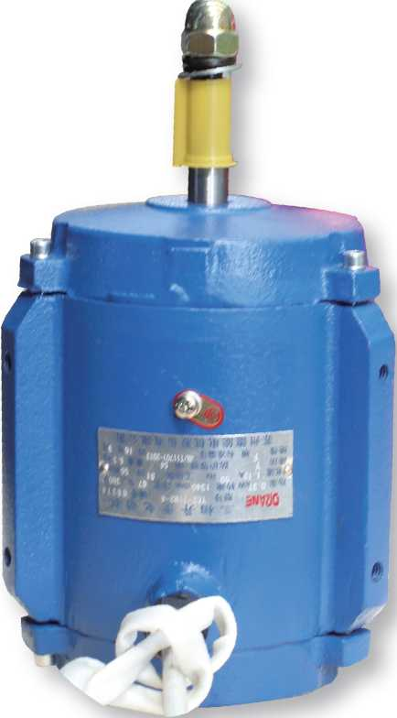

主要性能 Main Performance
•额定功率范围 Rated Power Range:0.4-7.5KW
•额定频率 Rated Frequency： 50Hz
•额定电压 Rated Voltage: 380V
•电机极数 Motor Poles: 2、4、6、8、10、12
•标准防护等级 International Protection Standard: IP54、IP55
绝缘系统：
按F级(155P )设计，在额定输出和直接供电时电机温升按80K考核；
电动机冷却方式：标准冷却方式为IC410自扇冷，依靠冷却塔冷却风进行冷却； 铸件材料：铸铁；
标准安装结构类型：IMV30;
电机可选用PTC或PT100热敏电阻进行绕组保护，也可加装绕组测温装置，160以上电 机可以选配轴承测温装置；
特殊设计：我公司可根据客户要求设计特殊电压、频率的电机；可根据客户要求调 整电机外观颜色，根据客户要求设计V1安装。
Insulation System:
According to the design of class F (155 DEG C) , in the rated output and direct power supply motor temperature rise according to 80K appraisal;
Cooling Method:standard cooling mode for IC410 self fan cooling, cooling by cooling tower;
Material: cast iron castings;
Standard installation structure of: IMV30、IM V1 etc.;
The motor can be used PTC or PT100 thermistor for winding protection, but also the installation of winding temperature measuring device, from frame 160 and up motor optional bearing temperature measuring device;
Special design: we can design special motor voltage and frequency according to customer requirements; can be adjusted according to customer requirements of motor appearance color. Design V1 installation according to customer's requirement.

DQANE
电动机/清洗机/自动化
Motor / cleaning machine / Automation
YSF3 series Exhaust fan series three-phase asynchronous motor

YSF3系列排烟风机用三相异步电动机
YSF3 series Exhaust fan series three-phase asynchronous motor

YSF3系列排烟风机用三相异步电动机

DQANE
电动机/清洗机/自动化
Motor / cleaning machine / Automation
安装与外形尺寸 Installation and configuration dimensions
性能数据 Performance Data
 |  |  |  | Power | Current 电流 |  |  | Torque 转矩 |  |  | Noise 噪声 dB(A) LW/LP
Type 型号 | Power 功率 kW | Speed 转速 r/min | Eff. 效率  % | factor 功率 因素 COS。 | 额定 电流 380V IN (A) | 额定 电流 400V IN (A) | 堵转 电流 额定 电流 IST/IN | 额定 转矩  TN  (N.M) | 堵转 转矩 额定 转矩 TST/TN | 最大 转矩 额定 转矩 TM/TN | Noise 噪声 dB(A) LW/LP

Synchronous speed 同步转速 3000r/min
Frame size | Installation dimensions and tolerances 安装尺寸及公差 |  |  |  |  |  |  |  |  |  | Configuration dimensions 外形尺寸
Frame size | B | C | D |  | E |  | F |  | G |  | S | H | AC | AD | L
机座  a | B | C | Basic dimenrsions 基本 尺寸 | Limit deviation 极限 偏差 | Basic dimenrsions 基本 尺寸 | Limit deviation 极限 偏差 | Basic dimenrsions 基本 尺寸 | Limit deviation 极限 偏差 | Basic dimenrsions 基本 尺寸 | Limit deviation 极限 偏差
56M | 50 | 55.5 | 9 | +OQO7 —0.002 | 20 | ±0.26 | 3 | 0  -0.030 | 7.2 | 0 -0.10 | M8 | 66 | 132 | 101 | 185
63M | 65 | 60 | 11 | +0.008  -0.003 | 23 | ±0.26 | 4 | 0  -0.030 | 8.5 | 0 -0.10 | M8 | 70.5 | 137 | 105 | 211
71M | 70 | 68 | 14 | +0.008  -0.003 | 30 | ±0.26 | 5 | 0  -0.030 | 11 | 0 -0.10 | M8 | 74 | 149 | 121 | 244
80M | 85 | 79.5 | 19 | +0.009  -0.004 | 40 | ±0.31 | 6 | 0  -0.030 | 15.5 | 0 -0.10 | M8 | 84 | 164 | 130 | 291
90S | 86 | 63 | 24 | +0.009  -0.004 | 50 | ±0.31 | 8 | 0 -0.036 | 20 | 0  -0.20 | M12 | 100 | 202 | 145 | 293
90L | 115 | 61 |  |  |  |  |  |  |  |  |  |  | 202 | 145 | 318
100L | 130 | 70 | 28 | +0.009  -0.004 | 60 | ±0.37 | 8 | 0 -0.036 | 24 | 0  -0.20 | M12 | 105 | 224 | 170 | 366
112M | 130 | 70 |  |  |  |  |  |  |  |  |  | 115 | 240 | 190 | 383
132S | 130 |  | 38 | +0.018  -0.002 | 80 | ±0.37 | 10 | 0 -0.036 | 33 | 0  -0.20 | M14 | 135 | 280 | 228 | 444
132M | 168 |  |  |  |  |  |  |  |  |  |  |  |  | 228 | 477

YSF3-5602 | 0.06 | 2800 | 62.0 | 0.68 | 0.32 | 0.3 | 5.0 | 0.2 | 2.2 | 2.2 | 61
YSF3-5612 | 0.09 | 2800 | 62.0 | 0.66 | 0.38 | 0.36 | 5.0 | 0.3 | 2.2 | 2.2 | 61
YSF3-5622 | 0.12 | 2800 | 65.0 | 0.71 | 0.38 | 0.36 | 5.0 | 0.4 | 2.2 | 2.2 | 61
YSF3-63M1-2 | 0.18 | 2800 | 65.0 | 0.8 | 0.5 | 0.48 | 5.5 | 0.61 | 2.2 | 2.2 | 61
YSF3-63M2-2 | 0.25 | 2800 | 68.0 | 0.81 | 0.7 | 0.67 | 5.5 | 0.85 | 2.2 | 2.2 | 61
YSF3-71M1-2 | 0.37 | 2800 | 69.0 | 0.81 | 1.0 | 0.95 | 6.1 | 1.2 | 2.2 | 2.2 | 64
YSF3-71M2-2 | 0.55 | 2800 | 74.0 | 0.82 | 1.4 | 1.33 | 6.1 | 1.8 | 2.2 | 2.3 | 64
YSF3-80M1-2 | 0.75 | 2825 | 75.0 | 0.83 | 0.8 | 1.71 | 6.1 | 2.5 | 2.2 | 2.3 | 64
YSF3-80M2-2 | 1.1 | 2825 | 77.0 | 0.84 | 2.6 | 2.5 | 7.0 | 3.7 | 2.2 | 2.3 | 64
YSF3-90S-2 | 1.5 | 2840 | 79.0 | 0.84 | 3.4 | 3.2 | 7.0 | 5.0 | 2.2 | 2.3 | 72
YSF3-90L-2 | 2.2 | 2840 | 81.0 | 0.85 | 4.9 | 4.7 | 7.0 | 7.4 | 2.2 | 2.3 | 72
YSF3-100L-2 | 3 | 2880 | 83.0 | 0.87 | 6.3 | 6 | 7.5 | 9.9 | 2.2 | 2.3 | 76
YSF3-112M-2 | 4 | 2890 | 85.0 | 0.88 | 8.2 | 7.8 | 7.5 | 13.2 | 2.2 | 2.3 | 77
YSF3-132S1-2 | 5.5 | 2900 | 86.0 | 0.88 | 11.0 | 10.5 | 7.5 | 18.1 | 2.2 | 2.3 | 80
YSF3-132S2-2 | 7.5 | 2900 | 87.0 | 0.88 | 14.9 | 14.2 | 7.5 | 24.7 | 2.2 | 2.3 | 80

Synchronous speed 同步转速 1500r/min
YSF3-5604 | 0.04 | 1400 | 56.0 | 0.58 | 0.28 | 0.27 | 4.0 | 0.28 | 2.1 | 2.2 | 52
YSF3-5614 | 0.06 | 1400 | 56.0 | 0.58 | 0.28 | 0.27 | 4.0 | 0.42 | 2.1 | 2.2 | 52
YSF3-5624 | 0.09 | 1400 | 57.0 | 0.61 | 0.39 | 0.37 | 4.0 | 0.63 | 2.1 | 2.2 | 52
YSF3-63M1-4 | 0.12 | 1400 | 57.0 | 0.72 | 0.44 | 0.42 | 4.4 | 0.85 | 2.1 | 2.2 | 52
YSF3-63M2-4 | 0.18 | 1400 | 60.0 | 0.73 | 0.6 | 0.57 | 4.4 | 1.3 | 2.1 | 2.2 | 52
YSF3-71M1-4 | 0.25 | 1400 | 65.0 | 0.74 | 0.8 | 0.76 | 5.2 | 1.7 | 2.1 | 2.2 | 54
YSF3-71M2-4 | 0.37 | 1400 | 67.0 | 0.75 | 1.1 | 1.05 | 5.2 | 2.5 | 2.1 | 2.2 | 54
YSF3-80M1-4 | 0.55 | 1390 | 71.0 | 0.75 | 1.6 | 1.52 | 5.2 | 3.7 | 2.0 | 2.3 | 58
YSF3-80M2-4 | 0.75 | 1390 | 73.0 | 0.76 | 2.0 | 1.9 | 6.0 | 5.1 | 2.0 | 2.3 | 58
YSF3-90S-4 | 1.1 | 1400 | 76.2 | 0.77 | 2.9 | 2.76 | 6.0 | 7.5 | 2.0 | 2.3 | 61
YSF3-90L-4 | 1.5 | 1400 | 78.5 | 0.79 | 3.7 | 3.5 | 7.0 | 10.2 | 2.0 | 2.3 | 61
YSF3-100L1-4 | 2.2 | 1420 | 80.0 | 0.81 | 5.1 | 4.8 | 7.0 | 14.8 | 2.0 | 2.3 | 64
YSF3-100L2-4 | 3 | 1420 | 82.6 | 0.82 | 6.7 | 6.4 | 7.0 | 20.1 | 2.0 | 2.3 | 64
YSF3-112M-4 | 4 | 1440 | 84.2 | 0.82 | 8.8 | 8.4 | 7.0 | 26.5 | 2.0 | 2.3 | 65
Y5F3-132S-4 | 5.5 | 1440 | 85.7 | 0.83 | 11.7 | 11 | 7.0 | 36.4 | 2.0 | 2.3 | 71
YSF3-132M-4 | 7.5 | 1440 | 87.0 | 0.84 | 15.6 | 14.8 | 7.0 | 49 | 2.0 | 2.3 | 71

Synchronous speed 同步转速 10OOr/min
YSF3-71M1-6 | 0.18 | 900 | 56.0 | 0.68 | 0.8 | 0.76 | 4.0 | 2.0 | 1.5 | 1.5 | 52
YSF3-71M2-6 | 0.25 | 900 | 59.0 | 0.68 | 0.9 | 0.86 | 4.0 | 2.8 | 1.5 | 1.5 | 52
YSF3-80M1-6 | 0.37 | 910 | 62.0 | 0.70 | 1.3 | 1.24 | 4.7 | 3.8 | 1.5 | 1.5 | 54
YSF3-80M2-6 | 0.55 | 910 | 65.0 | 0.72 | 1.8 | 1.71 | 4.7 | 5.7 | 1.5 | 1.5 | 54
YSF3-90S-6 | 0.75 | 910 | 69.0 | 0.72 | 2.3 | 2.2 | 5.5 | 7.8 | 2.0 | 2.0 | 57

90
91
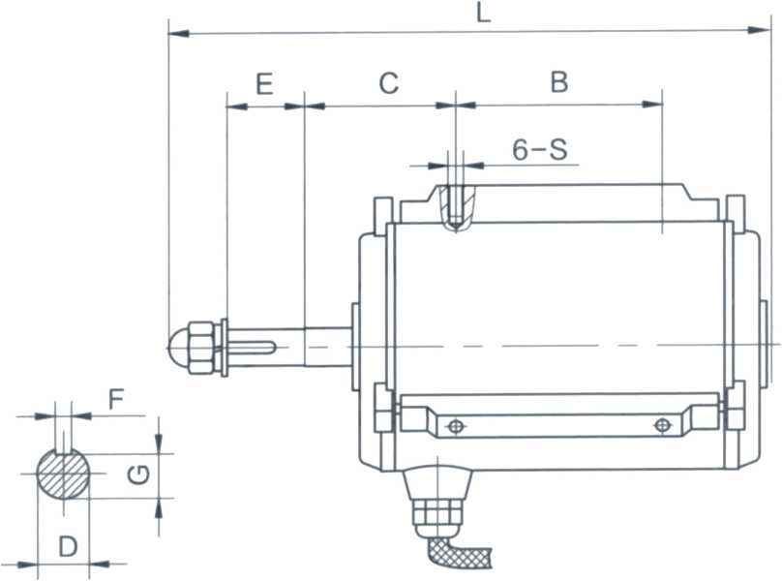
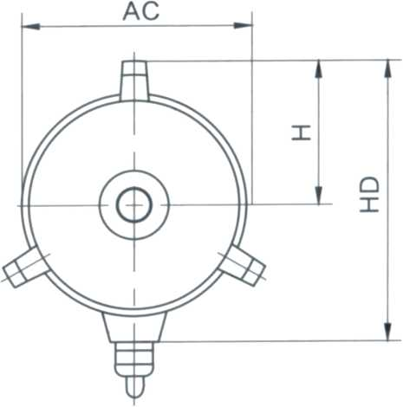

。站ME
电动疵洗枷自动化
Motor/cleaning machine / Automation
YSF3 series Exhaust fan series three-phase asynchronous motor

YSF3系列排烟风机用三相异步电动机
Color Card
电动机/清洗机/自动化
Motor / cleaning machine / Automation
性能数据 Performance Data
 |  |  |  | Power | Current 电流 |  |  | Torque 转矩 |  |  | Noise 噪声 dB(A) LW/LP
Type 型号 | Power 功率 kW | Speed 转速 r/min | Eff. 效率  % | factor  功率 因素  COS(|> | 额定 电流 380V IN(A) | 额定 电流 400V IN(A) | 堵转 电流 额定 电流 IST/IN | 额定 转矩  TN  (N.M) | 堵转 转矩 额定 转矩 TST/TN | 最大 转矩 额定 转矩 TM/TN | Noise 噪声 dB(A) LW/LP

Synchronous speed 同步转速 10OOr/min
► ral snaa
► ML 308D
► ML sons
YSF3-90L-6 | 1.1 | 910 | 72.0 | 0.73 | 3.2 | 3.0 | 5.5 | 11.5 | 2.0 | 2.0 | 57
YSF3-100L-6 | 1.5 | 940 | 76.0 | 0.75 | 4.0 | 3.8 | 6.0 | 15.2 | 2.0 | 2.0 | 61
YSF3-112M-6 | 2.2 | 940 | 79.0 | 0.76 | 5.6 | 5.3 | 6.0 | 22.3 | 2.0 | 2.0 | 65
YSF3-132S-6 | 3 | 960 | 81.0 | 0.76 | 7.4 | 7 | 6.5 | 19.8 | 2.0 | 2.0 | 69
YSF3-132M1-6 | 4 | 960 | 82.0 | 0.76 | 9.9 | 9.4 | 6.5 | 39.7 | 2.0 | 2.0 | 69
YSF3-132M2-6 | 5.5 | 960 | 84.0 | 0.77 | 12.9 | 12.3 | 6.5 | 54 | 2.0 | 2.0 | 69

Synchronous speed 同步转速 750r/min
► RAL 5007
► RAL 5010
► FIAL 501S
YSF3-100L-10 | 0.37 | 560 | 61.0 | 0.61 | 1.5 | 1.43 | 4.0 | 6.3 | 1.8 | 2.0 | 56
YSF3-100L1-10 | 0.55 | 560 | 60.0 | 0.61 | 2.3 | 2.19 | 4.0 | 9.4 | 1.8 | 2.0 | 56
YSF3-100L2-10 | 0.75 | 560 | 64.0 | 0.61 | 2.9 | 2.76 | 4.0 | 12.8 | 1.8 | 2.0 | 59
YSF3-112M-10 | 1.1 | 570 | 65.0 | 0.63 | 4.1 | 3.9 | 5.0 | 18.4 | 1.8 | 2.0 | 59
YSF3-132S-10 | 1.5 | 570 | 81.0 | 0.64 | 4.4 | 4.2 | 5.0 | 25.1 | 1.8 | 2.0 | 64
YSF3-132M1-10 | 2.2 | 570 | 78.0 | 0.64 | 6.7 | 6.4 | 6.0 | 36.9 | 1.8 | 2.0 | 64
YSF3-132M2-10 | 3 | 570 | 80.0 | 0.64 | 8.9 | 8.5 | 6.0 | 50 | 1.8 | 2.0 | 64

Synchronous speed 同步转速 600r/min
► RAL 5019
► HAL 7031
► HAL 7D3E
YSF3-90S-12 | 0.25 | 450 | 47.0 | 0.5 | 1.6 | 1.52 | 4.0 | 5.3 | 1.8 | 2.0 | 56
YSF3-90L-12 | 0.37 | 470 | 50.0 | 0.54 | 2.1 | 2 | 4.0 | 7.5 | 1.8 | 2.0 | 56
YSF3-100L-12 | 0.37 | 470 | 54.0 | 0.5 | 2.1 | 2 | 4.0 | 7.5 | 1.8 | 2.0 | 59
YSF3-100L1-12 | 0.55 | 470 | 55.0 | 0.51 | 3 | 2.85 | 4.0 | 11.5 | 1.8 | 2.0 | 59
YSF3-100L2-12 | 0.75 | 470 | 56.0 | 0.51 | 4 | 3.8 | 4.0 | 15.2 | 1.8 | 2.0 | 59
YSF3-112M-12 | 1.1 | 480 | 62.0 | 0.56 | 4.8 | 4.6 | 5.0 | 21.9 | 1.8 | 2.0 | 59
YSF3-132S-12 | 1.5 | 480 | 65.0 | 0.58 | 6 | 5.7 | 6.0 | 29.8 | 1.8 | 2.0 | 64
YSF3-132M-12 | 2.2 | 480 | 76.0 | 0.58 | 7.6 | 7.2 | 6.0 | 43 | 1.8 | 2.0 | 64

Synchronous speed 同步转速 500r/min
YSF3-112M-16 | 0.37 | 350 | 44.0 | 0.47 | 2.7 | 2.57 | 5.0 | 10 | 1.8 | 2.0 | 59
Y5F3-132M-16 | 0.55 | 350 | 55.0 | 0.45 | 3.4 | 3.23 | 6.0 | 15 | 1.8 | 2.0 | 64

Synchronous speed 同步转速 375r/min
► FIAL 9005
► fial suns












